Real World “Character Sheet”

# Provided pitch on canvas

“People often make consistent superficial judgements of a strangers’ personality and life from their appearance. While these judgements can often be very inaccurate, the fact that many people can feel a similar way is interesting and can be used to reveal cultural bias and measure the limits of human intuition. The goal of this project is to create a realistic ‘character sheet’ as a json datastructure that defines a person and their appearance in an image. By getting crowd workers to label fictional and real people we can analyse how people make judgements about others and how accurate and consistent such judgements can be.

Start by focusing on the visual appearance of an image of a person using existing academic taxonomies (for example, describing the clothes they are wearing using **X**) for areas that have yet to be formalised like haircuts and makeup, develop ways of formalising them using websites or online guides (e.g. for describing a person’s glasses they could be labelled with the closest equivalent specsavers product id).

Add invisible personality metadata – for example high level personality judgements like those used in the open psychometrics fictional character survey ([https://openpsychometrics.org/tests/characters/ (Links to an external site.)](https://openpsychometrics.org/tests/characters/)).

Add career and education estimates (what job they might do, what subjects they studied at university) (net worth)

Add romantic relationship estimates (given other images and descriptions identify the most likely partner) (potentially historical estimates e.g. many partners one, none etc.)

Friendship relationships

Family relationships

Hobby and entertainment interests – what films, music, part time activities most interested in

Medical conditions

Religious views

Weight, Height, clothing measurements

Possible names the person might have (implying nationality, class, age etc.)

Create amazon mechanical turk application to take an image of a person and fill in the corresponding character sheet data through a long questionnaire

Use images of imaginary people produced by stylegan2-ada (keeping track of the input vector, so it can be used to reproduce the images and train computer vision algorithms in the future)

https://github.com/NVlabs/stylegan2-ada

Gather images of semi-famous people (leaders of their profession but not widely known), with known information from Wikipedia e.g. profession, nationality, weight, height etc.

Use stylegan ada to get their appearance signature from their facial appearance

As there are many areas to formalise within the character sheet, multiple students can work together each focused on formalising a different part of the character sheet.

***Language and Platform***

Python and PySelenium scripts for webscraping to define a taxonomy e.g. scraping specsavers glasses images and their corresponding ids)

Amazon’s mechanical turk

***Further work – system should be able to expand to perform this functionality but doesn’t need to do it for V1 (the main focus of the module)***

Can train a stylegan-ada system to take an image and estimate properties of the person, also can adjust character sheet information to adjust the appearance”

# My work week

I should generally have Monday - Friday free to work on the project unless otherwise stated, unfortunately i work every saturday and so won’t be able to do work then.

# Table of Contents

**Provided pitch on canvas** **2**

**My work week** **3**

**Table of Contents** **4**

**Week 1 (10th - 17th Jan)** **8**

First few days: Mon 11th - Wed 13th 8

First Impressions 8

Thurs 14th 8

Fri 15th 8

**Week 2 (17th - 24th jan)** **9**

Mon 18th 9

Tues 19th 9

Wed 20th - First meeting 9

Goals for meeting with John 9

Notes from meeting 9

Thursday 21st 9

Friday 22nd 10

**Week 3 (24th - 31st jan)** **10**

Mon 25th 10

Tues 26th 11

Wed 27th - Second Meeting 11

Notes from meeting 11

Thurs 28th 12

Fri 29th 12

**Week 4 (31st jan -7th feb)** **13**

Mon 1st 13

Tues 2nd - 3rd Meeting 14

Notes from meeting today 14

Wed 3rd 14

Thurs 4th 15

Fri 5th 16

**Week 5 (7th feb - 14th)** **18**

Mon 8th 18

Tues 9th 18

Wed 10th - 4th meeting 19

Meeting notes 20

Thurs 11th 20

Friday 12th 22

**Documentation of Woctezumas notebook (Preparation Section)** **22**

**Week 6 (14th Feb - 21st)** **25**

Monday 15th 25

Tues 16th 26

Wed 17th 27

Meeting notes 27

Thurs 18th 29

Fri 19th 30

**Week 6 (21st Feb - 28th)** **30**

Mon 22nd 30

Tues 23rd 30

Wed 24th 30

Meeting Notes 31

Thurs 25th 32

Fri 26th 32

**Week 7 (28th Feb - 7th March)** **33**

Mon 1st 33

Tues 2nd 33

Wed 3rd 33

Meeting Notes 34

Thurs 4th 35

Fri 5th 37

**Week 8 (7th March - 14th)** **39**

Monday 8th 39

Tuesday 9th 40

Wed 10th 40

Meeting Notes 40

Thurs 11th 40

Fri 12th 40

**Week 9 (March 14th - 21st)** **40**

Mon 15th 40

Tues 16th 41

Wed 17th 42

Thurs 18th 42

Fri 19th 42

**Week 12 (March 21st - 28th)** **43**

Mon 22nd 43

Tues 23rd 43

Wed 24th 43

Meeting today 43

Thurs 25th 43

Fri 26th 44

**Week 13 (March 28th - April 4th)** **44**

Mon 29th 44

Tues 30th 44

Wed 31st 45

Thurs 1st 46

Fri 2nd 46

**Week 14 (April 4th - 11th)** **47**

Mon 5th 47

Tues 6th 47

Wed 7th 47

Thurs 8th 47

Fri 9th 47

**Week 15 (April 11th - 18th)** **47**

Monday 12th 47

Tues 13th 48

Wed 14th 50

Thurs 15th 51

Fri 16th 51

**Week 16 (18th April - 25th (48hr Deadline extension)** **51**

Monday 19th 51

Tuesday 20th 51

Wed 21st 52

Thurs 22nd 53

Fri 23rd 55

Saturday 24th 56

Sunday 25th 56

# Week 1 (10th - 17th Jan)

## First few days: Mon 11th - Wed 13th

These days were spent decision making on which project choice i wanted to go for, i chose this project as my first choice as it seemed incredibly challenging but equally interesting.

## First Impressions

* Firstly it is based on a json data structure which i have never worked with so i have to do research on that
* On top of this my python would be rusty
* This project definitely feels like it could have a lot of ethical concerns
* In my mind this project could be easily split into 3 parts:
  + Determining characteristics of the person from their clothes
  + Determining characteristics of the person from their facial structure, skin tone, hair style, wrinkles etc
  + Determining the relationships of the person using the previous two pieces of data, combined with pictures of the person with other people

## Thurs 14th

I decided to test the wikidata client that John had talked about in his initial email.

Originally i tried to use the Spyder IDE however i could not import the client

I simply moved onto the Idle application instead and the plugin worked with ease

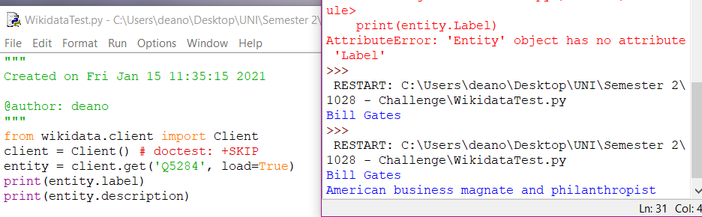

## Fri 15th

* Looked into the idea of “invisible personality metadata” through the openpsychometrics which character quiz, through this we could take the looks of a person and assign personality assumptions to them, then use these assumptions to determine other things about their life

# Week 2 (17th - 24th jan)

## Mon 18th

* Briefly looked at web scraping, however i believe this would only be relevant if i went into the fine details of looking into exact clothing/accessories worn and determining characteristics from that

## Tues 19th

* I’m starting to realise I'm going to have to bite the bullet and figure out how github works. This really isn’t the sort of project i want to lose due to hard drive failure and i’ve heard good things about githubs version control.
* Created a github account the sent off for the student developer pack

## Wed 20th - First meeting

### Goals for meeting with John

* Determine what aspect i will be doing
* Discuss ethical concerns
* Determine where to go from here, i feel as if i have a large amount of information and potential, but not alot of direction

### Notes from meeting

* Don’t have to be reasonable or rational with machine learning.
* Don’t look too far into what eg “charismatic” is, all we care about is accurately predicting what other human beings are thinking.
* Look into tortoiseGit
* Need alot of diverse pictures of people
* Diversity of people, eg careers, location etc
* We want to be able to use stylegan stuff
* Try to get <https://github.com/RameenAbdal/StyleFlow> running
* Me: should focus on pictures of people (including full length shots?)
  + Find references to collections of photos + about 10 sample photos
* Nathan: should focus more on the properties of a person (+ making a website?)

## Thursday 21st

* New target is to get StyleFlow up and running, John has said that the best place to get it up and running is on ubuntu.
* Currently my pc is dual booting linux mint, so i will have to delete this partition and then create a new ubuntu boot option
* I also recognise that this ubuntu dual boot may need a decent amount of storage (for images) so i’m going to give it a partition of 117gb on my hard drive.
* After 5 frustrating hours and 6 separate installation attempts i’ve given up for the day and shall try to tackle the problem after sleeping on it. I keep getting fatal errors near the end of ‘grub-install /dev/sda’ failed which online solutions for do not seem to be helping

## Friday 22nd

* Took another attempt at installing ubuntu, same error
* Messaged John to ask if simply using a virtual machine would be possible however i could only afford to give it about 4gb of ram
* Virtual Machine has been set up, feels good to have actually made what feels like some progress
* Downloading git then anaconda on the virtual machine first in preparation for running styleflow, although i doubt performance will be fantastic
* Installed anaconda to create the environment
* Computer crashed a couple of times during installations and then when trying to set up environment, maybe running out of resources? I will research more on monday, having quite a frustrating lack of progress

# Week 3 (24th - 31st jan)

## Mon 25th

* Going to attempt to get styleflow running on the virtual machine again, this is the error given when i attempt to create the environment

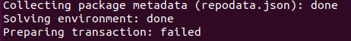

* Only threads i found on this error were unresolved
* Have received this error multiple times
* Switching approach, going to attempt to use google colab to run the environment
* Colab seems like it could be a fantastic tool but also seems a tad complicated, currently i feel like i'm trying to throw together two things i don’t understand but i’ll do my best
* Unfortunately wasn’t able to get any productive output from google colab today

## Tues 26th

* On the styleflow page i have spotted a beta WebUI version. My thoughts are that this version could be slightly easier to run so im going to attempt to start it on the ubuntu virtual machine
* I attempted this on the virtual machine and it did not work. However i noticed the gif demonstrating it was actually on windows 10 pc so i will attempt to do it on windows
* Unfortunately i have ran into errors and it “failed to build pyarrow” as it is on a windows machine
* Going to take another go at google colab
* Used this tutorial: <https://towardsdatascience.com/conda-google-colab-75f7c867a522> to install conda on google colab
* Receiving error ‘ModuleNotFoundError’ about pyqt5

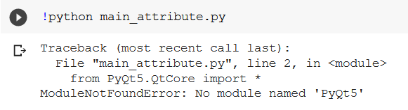

* After googling it turns out it is another optional module which i will have to get
* Same thing happened with ‘qdarkstyle’,‘qdarkgraystyle’,‘cv2’(open cv), ‘sklearn’, ‘tensorflow’, ‘tensorflow.contrib’
* Upon not being able to find the module ‘tensorflow.contrib’ googling only seemed to show that tensorflow.contrib doesn’t exist in recent versions
* Will try to figure out best path forward in meeting tomorrow

## Wed 27th - Second Meeting

### Notes from meeting

* Character sheet will contain json file + picture(s)
* Options:
  + Styleflow is best that exists
  + Existing guides arent very good - could do a how to guide on this
  + Try to make styleflow easier to run
    - Ubuntu machine + nvidia card
    - Docker image with webserver
    - Docker image on cloud
    - Modify the program so that it runs in google colab
* Get stylegan 2 ada up and running and train it (use transfer learning?)
* Find banks of photos, profile shots etc

## Thurs 28th

* New objective is to train a StyleGAN-2-ada model from scratch using google colab, and i will be writing a guide on how i achieved this

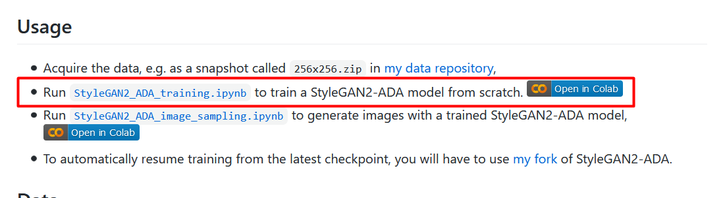

Guide page: <https://github.com/NVlabs/stylegan2-ada#preparing-datasets>

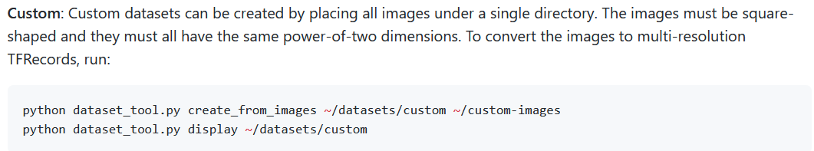

* Registered for and downloaded chicago university face images with attractiveness
* Error in unzipping the file, potentially in the wrong format?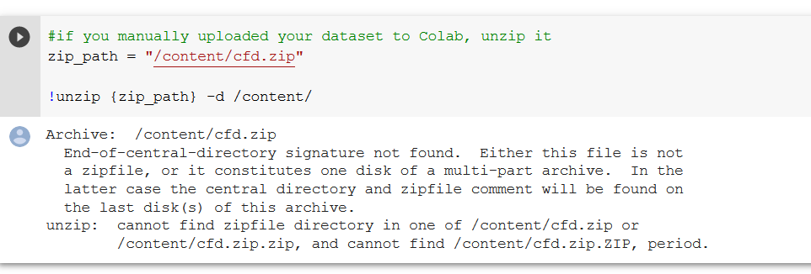
* I have also realised that the chicago university face images are not square (e.g 512x512) so i must find another dataset

## Fri 29th

* Firstly i have to find a new, appropriate dataset
* Messaged john asking about how this all actually works, as in my eyes we are training the network with just photos, without the external data strapped to the photos, he has said that an additional codebase is needed to do that.
* Took a few steps back and watched a few videos on GAN’s to better understand what exactly i’m working with
* Spent most of today researching Gans.

# Week 4 (31st jan -7th feb)

<https://androidkt.com/convert-tfrecords/>

<https://github.com/NVlabs/stylegan2-ada#preparing-datasets>

<https://www.microsoft.com/en-us/download/details.aspx?id=54765>

## Mon 1st

* I have to produce a guide for friday so i need to get things working, in order for my data to work with stylegan2-ada i must be able to convert it to a .tfrecords file, so i must find data which can do this
* “The TFRecord format consists of a set of shared files where each entry(image) is a serialized tf.Example proto. Each tf.Example proto contains the image as well as metadata such as label and bounding box information.”
* A simple way of applying labels seems to be having subfolders which are named the label of the image e.g /dataset/dog and /dataset/cat subfolders
* I'm going to see if i can find a cats vs dogs dataset to test this on
* Found a dataset with subfolders for cats and dogs however the images are not in set resolutions and therefore i cannot convert it to a tfrecords file
* Attempted to use this page: <https://www.tensorflow.org/datasets/overview#tfdsload> to load in the cats_vs_dogs dataset directly as a tfrecords file. However to use this command i must be on version 2.1.0 of tensorflow but stylegan2-ada only works on 1.15.2
* Going to attempt to set up a version 2.1.0 tensorflow environment, download the .tfrecords file of cats_vs_dogs to my drive on one colab setup. Then on the actual colab setup use this file for the stylegan2-ada training on version 1.15.2
* So far this has been successful, managed to load the cats vs dogs.tfrecords file however it gave me it in the form of 8 parts
* I have now realised that even if i have a .tfrecords file of cats_vs_dogs it will still have non square images which stylegan2-ada cannot work with so im going to attempt to use pillow to adjust the images
* Have created my own python program to resize and replace images with a 512x512 version
* Ran into multiple errors in making this program, one was due to the image not being in rgb format so i added code to ensure it was
* Another was that the ‘file was already in use’ so i made the program sleep then retry the delete until it worked
* Resizing is working surprisingly well but it is quite slow, some images are slightly squashed looking but i hope this doesn’t affect the results too much
* All images resized now, going to pack it into a zip file for use on colab
* Will upload to drive now, going to take a few hours so i’ll finish my day on that

## Tues 2nd - 3rd Meeting

* Objective today is to train the network using the resized cat + dog images from yesterday
* Currently i have two folders - catsvsdogs/cats and catsvsdogs/dogs
* Theoretically i can convert the catsvsdogs file to .tfrecords and the cats and dogs subfolders will act as labels for the images within them
* However when i try to do this the dataset_tool.py create_from_images function complains that I'm pointing it to the catsvsdogs directory rather than images.
* I'm going to see if there are any other functions in dataset_tool.py that would work with what i have
* It looks like under the tensorflow repository itself on github there is a build_image_data.py which takes subfolders as labels which is exactly what i would want. However it also seems to create a sharded set of .tfrecord files rather than one big file which is not what i want
* I think simply so that i have actually trained something i am going to train the network on just the cat images

### Notes from meeting today

* Dogs.tfrecords + cats
* NumPy thing for .labels file
* NP.save to make it
* Number of dimensions ==2
* One dimension = value of the labels, other is the image
* First dimension how many images there are, second is
* Focus on doing what i can to explain to get to where i am with StyleGan
* This is what other people have recommended, here are the links etc
* Key thing to get sorted is to generate the .tfrecord file
* Not about showing your intelligence/ that you did something that was hard, simply more about communicating something well

## Wed 3rd

* Now have to place my focus more on one of the assessed parts of the course, the assessed parts are:
  + A web page (blog post/medium post etc.) beginners guide on learning about and getting started with a new technology
  + Weekly diary
* After talking to a couple of my friends who are interested in the data analytics field they agreed it would be useful to have a guide which really takes you from the basics (i.e me a few weeks ago) as it is quite a daunting yet interesting topic.
* I would like for the guide to contain steps which every tutorial seemed to brush over, i would like answers for questions i found myself having e.g:
  + “How do i find a dataset?”
  + “How big should a dataset be (images/gb)?”
  + “What format does the dataset need to be in, do i just need pictures?”
  + “How is the data within the dataset given properties?”
  + “Once I have a good dataset, how do I convert it to something that stylegan2-ada can interpret?”
* A potential title could be “How to set up and train a StyleGan2-ada network on a custom dataset [WIP]”

## Thurs 4th

* Have to make the majority of the progress on my web page today
* Have thought about who would actually be interested in this web page and how it could be utilised. I genuinely think that there are many many computer scientists who have always been interested in the field of Data Science but have never took steps to pursue it because of just how different it is. I think that a guide that talks in simple language and could take anyone right up from basics would be of great utility to the field of computer science as a whole. I certainly know that starting out I would have loved to have found a guide like what mine will be.
* I believe the target audience is computer scientists of any skill level who have a keen interest in but have never looked into the field of data science.
* In my searches online for tutorials i found some articles which dealt with finding datasets, some which dealt with preparing images and some which dealt with training the network. However i found no simple guide which brought all of these things together.
* I’m definitely think i can get sections on finding my dataset and preparing it, but im not so sure i could make a good tutorial on converting to .tfrecords as i haven’t managed to get this working along with labels yet
* In writing my guide i have came across the issue that there are articles which explain what i am going to say. So i have to answer, would answering the question be better if it was a link to the article, gave a summary and then linked it, or fully explained it then linked it.
* In order to answer this question John advised that i should ask people who would be interested in.
* I got the two comments

“no summarised definitely, unless it's a CORE CORE part of your process”

And

“Depends how well the article explains it. No point explaining it twice

But if you would explain it better then do an explanation aswell”

* From this it seems that a common sense, but mostly summarised approach would be better
* Even actually trying to answer the question “what makes a good dataset” is very difficult as it seems very case dependant
* I am replacing some of my longer paragraphs with bullet points. If you look at other how to guides e.g <https://www.tutorialspoint.com/tensorflow/tensorflow_installation.htm> you definitely notice the complete lack of large blocks of text and i think this would be good to incorporate into my work. I personally believe large blocks of text take alot of willpower to focus through and if i was to have many of them then the reader would lose interest entirely.
* Upon reading more articles online about data analytics, i have also realised that this guide would be very useful for someone who wants to get into the field of data analytics and needs to build up a portfolio.
* Previously i had just stretched out my cat and dog images to 512x512 however i want this guide to do things to correct way so im figuring out how to use padding instead.
* I will then simply provide my code and give the user instructions on how to run it on their dataset
* I believe this part is also very useful to others as i had to check out a couple of tutorials and write the code to do this part myself whereas other users can simply install python and PIL then run my code.
* Before I continue with my “preparing the dataset” part past the resolution, I'm going to have to figure out conversion to tfrecords. As i'd like to make a section on how to work with the labels, i’m checking out this video <https://www.youtube.com/watch?v=oxrcZ9uUblI>
* <https://www.xspdf.com/resolution/51318067.html> - Useful seeming link

## Fri 5th

* Today i need to work finish the web page
* I feel i need to include info on labelling, my way of labelling my files is through subfolders which the program will detect labels based on my cats + dogs subfolders shown here: <https://androidkt.com/convert-tfrecords/>
* There are other resources on setting up your own labels via things such as csv/xml files however i think given my time constraints i dont have time to figure this out and implement a tutorial on it on top of the section of converting to .tfrecords. Especially since pretty much every time i have tried to figure out the other labelling options i have felt very overwhelmed and confused. In watching a tutorial video on the topic the youtuber constantly complained about how uncommented and hard to understand the api was, which was quite a relief for me
* So for now my labelling section will just be on using subfolders
* I am also finding that alot of resources online are recommending splitting the dataset down into training, validation and testing sections. With training being the biggest chunk. I am not entirely sure if i need to do this (im thinking if i do need to add this then i can do so in future).
* I am also quite worried that i’m doing this very wrong and therefore that the web page therefore won’t be useful. But i suppose this is just the reality when working with a technology that is new to you
* 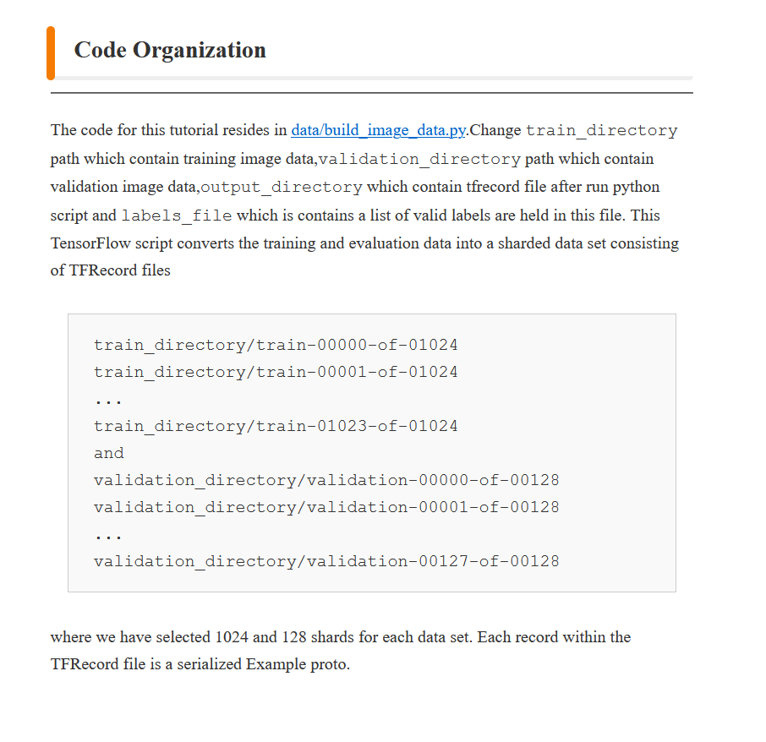
* According to this it’s looking like i will need to split my data into a train and then a validation set
* This article is probably the best i’ve found for my current situation so i think i would be better off following it
* Going to insert info on training sets and validation sets as i understand it, to really ensure the web page could take someone from the basics.
* Im not sure if i will need a test set but i will go back and add this info if needed
* Making a complete estimate on how i should proportion my validation set vs my training set. Going for 500 validation images vs 12k training.
* Finally onto the converting to .tfrecords section, the final one i intend on doing before the deadline later. Hopefully i can get the conversion working successfully
* I’m actually really enjoying making this how to guide and i think it is really helping to reinforce my understanding of the topics
* I also think it would be genuinely useful to someone starting out
* Had conda installed but had a bit of difficulty getting conda commands to work on the command line so that i could install tensorflow
* Ran out of space on my C drive during installation so now need to free some up
* Im now also receiving the error shown here <https://github.com/tensorflow/tensorflow/issues/34722>
* I think the installation didn’t work properly as it ran out of space when installing and that’s why the module wouldn’t work right, so i’m reinstalling
* I am now receiving an error that i have no module named ‘_pywrap_tensorflow’
* According to a stackoverflow page i have to downgrade my python and mirosoft visual c++ redistributable
* I believe i can maybe do this inside of a conda environment
* Getting an http error when i try to create a conda environment
* Need to add more paths to my environment variables, feeling very thankful for stack overflow
* Even after doing this still receiving same error
* It unfortunately doesn’t look like im going to get this running before the deadline, however i still think i should keep my converting to .tfrecords file guide as is because these errors could just be something to do with my specific situation.
* That being said once i get it working properly if the guide needs adjusted i will adjust it
* Admittedly it feels a little disingenuous to be telling someone a method to do something that i can’t even get to work myself. However the guide here: <https://androidkt.com/convert-tfrecords/> basically follows the same procedure therefore it must work under usual circumstances.
* Looking back on my now completed work i would have been incredibly happy to have a guide like this when i was starting out and i feel it would be a very useful asset for anyone trying to get into machine learning as it compiles all of the relevant information, rather than what i had to do which was scramble through random articles trying to find information relevant to what i was trying to achieve. I also believe i have made the web page as concise as possible so i believe this would also help encourage readers. There is nothing more off putting than going on to a guide and seeing massive page sizes and walls of text, and these are things i think i have avoided quite well.
* So the web page is now as complete as it is going to be for the 12 o’clock deadline, hope everything reads well.

# Week 5 (7th feb - 14th)

## Mon 8th

* Decided to relax today, just going to look over feedback and pick out what it means for me practically
* I need to:
  + Continue working with my StyleGan model and hopefully get it working
  + Fully complete my how to guide
  + Try to convert everything from the how to guide into running on colab
  + Make the guide more certain and be confident in it working
  + Try to produce a gif to demonstrate the value of the guide right at the beginning

## Tues 9th

* Continually failing to ‘load the native tensorflow runtime’ as i try to build the .tfrecords file
* Going to attempt this within colab as i think it could be due to me not having an nvidia gpu
* This will involve uploading dataset to google drive so that colab can access it which is going to take a bit.

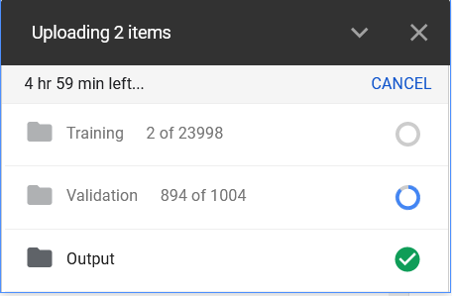

* Going to have to just wait this out
* Only got finished at 7pm and i’ve spent most of the day working on other modules. Probably going to call it a day

## Wed 10th - 4th meeting

* Have to access files on google drive using colab, first i have to mount my drive
* Then i have to install stylegan 2 and utilise build_image_data
* Trying to run conversion to .tfrecords code getting error with flags
* Solution is to clear flags but i am getting errors pbd post_mortem errors
* Apparently this is due to the pbd (python debugger) module of python (which should come with it) not being installed

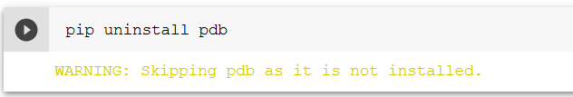

* Confirmed this by attempting to uninstall it

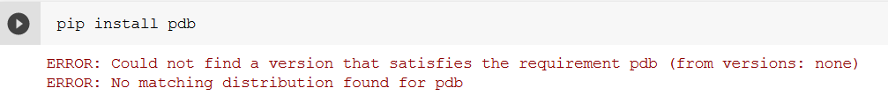

* However i also cant install it, think i have to manually download and add it to my python files

## Meeting notes

* I need to run woctezumas code, get it working
* Then add my padding work
* My general piece of work will be “making stylegan2-ada more accessible”, really trying to explain the things that other guides have simply glossed over
* Continuing today trying to run woctezumas code
* Running into a syntax error within train.py which seems very strange, contacting John about it.
* “If you look through the notebook expanding out each section you will see that it is copying from MyDrive/datasets/stream and putting into the collab local storage /content/datasets/stream.
* The training code then has an initial training step described as transfer learning (this is commented out but needs uncommenting) There may well be other typos that cause errors but the previous steps are needed.
* As Stylegan is the focus of your project I think it is a good idea to write down a bit on each step of the notebook, google the import libraries and see if you can understand what each part is doing. Please ask and I will try to investigate.
* It is also valuable to open and try to read/document the train.py file from github. The less it is a set of magical commands the more it will be something you can debug and control.
* Once you have a valid folder of training data as tfrecords using the utility scripts from NVLabs then we can see where the error lies.”

## Thurs 11th

* Dataset has been extracted and uploaded
* Going to go through and try to understand each section of the Woctezuma notebook, i will create a separate header for this and add to it as i work through the notebook
* Going to try to run the notebook so far and get this .tfrecords file
* Edited one of the cells as it didn’t seem correct, rather than pointing it to my dataset it was pointing at a folder i didnt have called ‘data’/
* 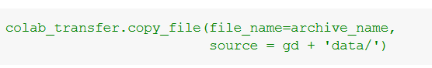

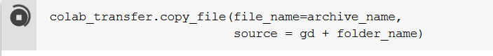

* It also looks like the dataset needs to be in tar format, as when i attempted it with a .zip file the extraction part here:

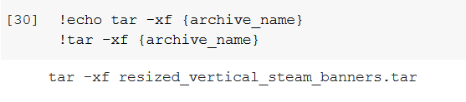

threw errors that it wasnt type tar

* However within the actual github page the author gives 256x256.zip as an example dataset to use



* I have successfully decompressed the folder: 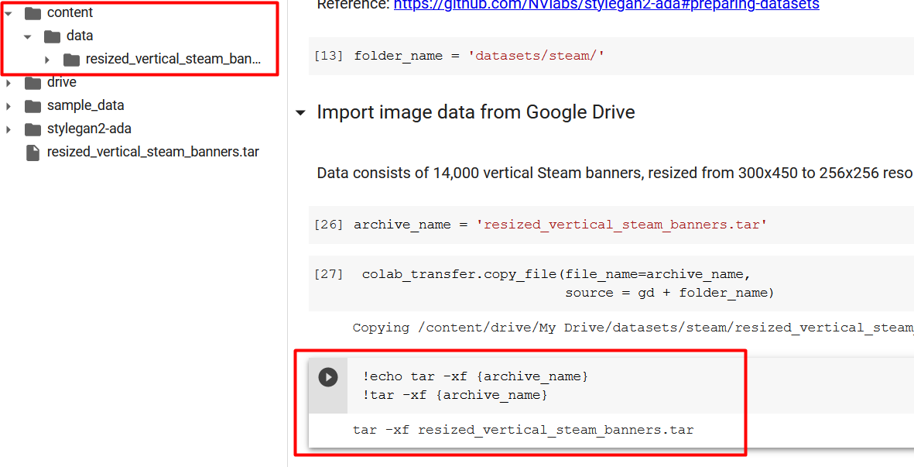
* Things were running too smoothly so i now have a random error from running the create_from_images command: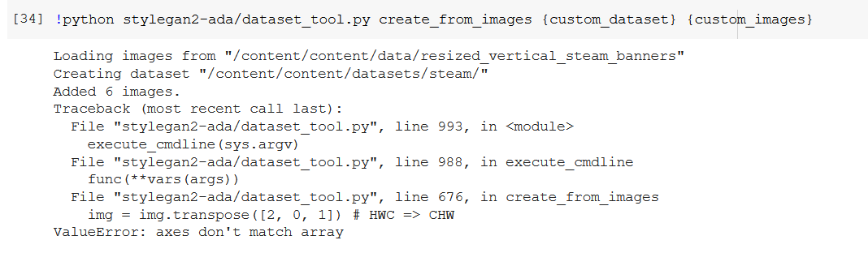
* Going to try tackle the problem myself before going to John
* It looks like the error could have been caused by images being in the wrong format:

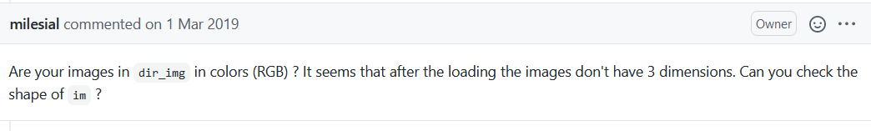

* I am going to choose one of the highly filtered datasets instead, because he said that the filtering of banner images consisted of removing “banners with uncommon bands (anything but rgb)
* Looking much more positive now in dataset creation but it looks like its going to take a while
* Created tf records, uploaded them to my drive

## Friday 12th

* Worked on a documentation of woctezumas notebook for the day
* Tried to get network trained and but ended up getting a strange syntax error, going to send John a message and pick it back up on monday

# Documentation of Woctezumas notebook (Preparation Section)

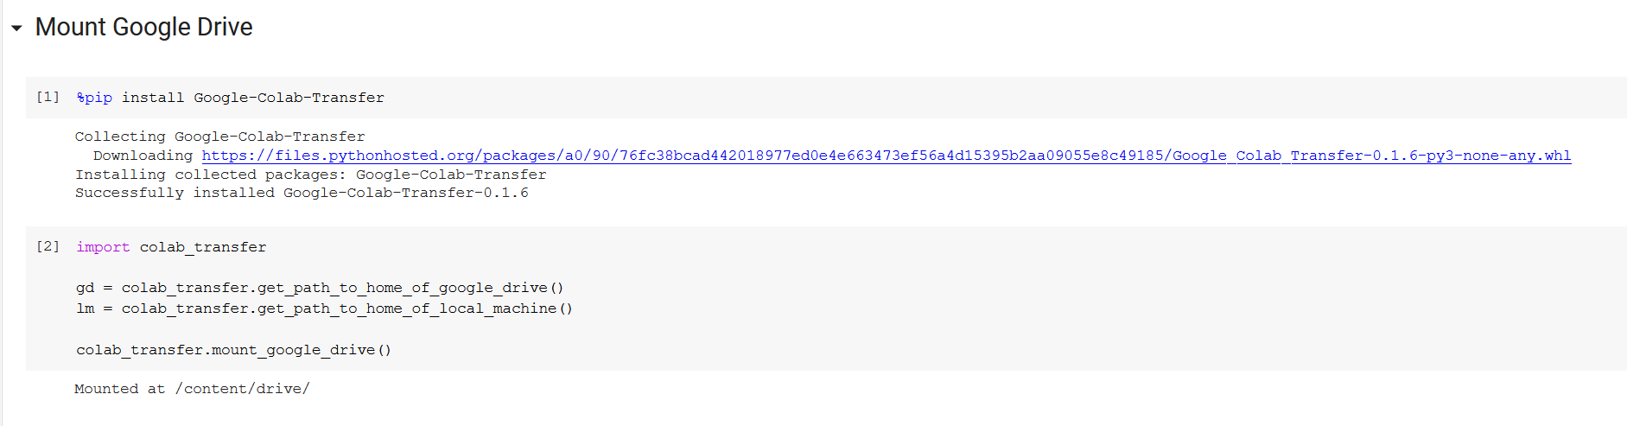

First we install google colab transfer then we use this module to get:

1. The home path of our google drive
2. The home path of the local machine

Then we use the module to mount or own drive in order to access the images

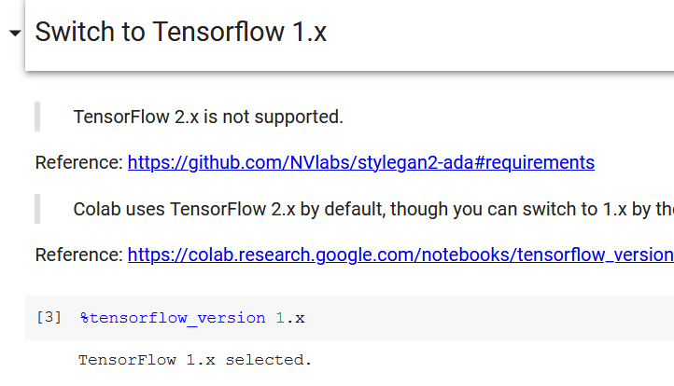

Selecting the version of tensorflow to be 1. Something. As this is what StyleGAN2-ada has to work with

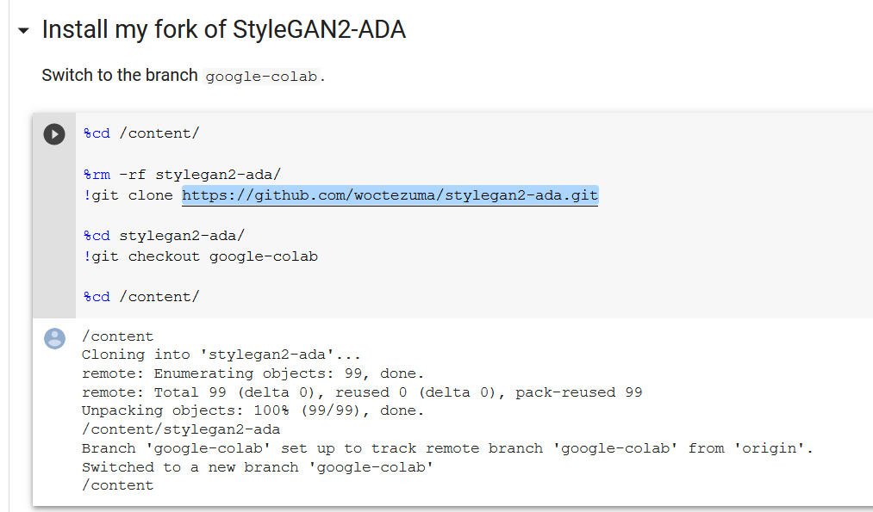

We then install woctezumas copy of the StyleGAN2-ADA repository, this is known as a fork

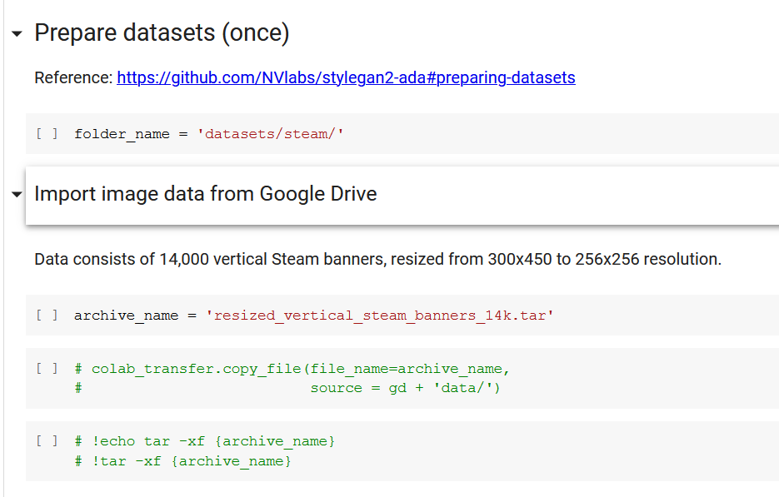

Then we prepare the datasets, we do this by uploading one of the compressed image banks to our google drive, then pointing these commands at our folder. And letting it run. This will decompress and then add our images to the local machines files.

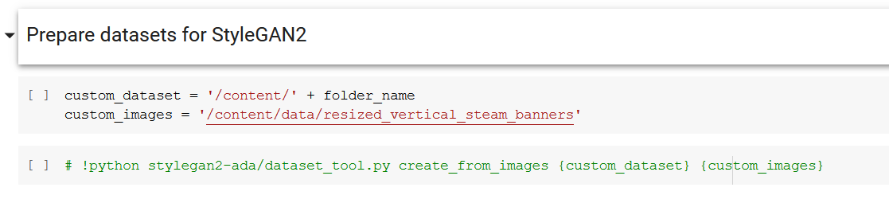

This cell converts the decompressed file to .tfrecords once it is on the local machine

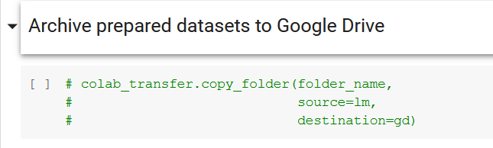

This cell saves the generated .tf records files to google drive from the local machine

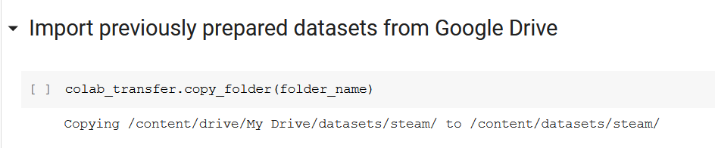

This cell loads the .tfrecords files from google drive to the local machine

# Week 6 (14th Feb - 21st)

This week is technically reading week but i’d rather keep getting on with the work (full lockdown so might as well spend my time on something productive)

## Monday 15th

* Goal Today is to fix error from friday and get the network training
* Syntax error is in the colab notebook version but not on the github version which is strange, going to manually download, edit and reupload the train.py file
* Also had to change --cfg to auto instead of auto_no_ramp
* And i had to remove the --cfg_map=8 \ parameter
* It is taking a very long time to do the initial run (6h so far)
* Despite efforts to make it not cut out it seems the virtual machine has done this anyways
* Trying to reconnect i am getting this error
* 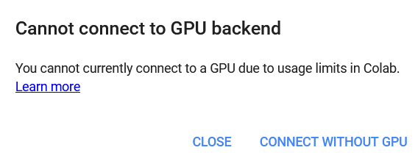
* Looking at files however i have generated output:
* 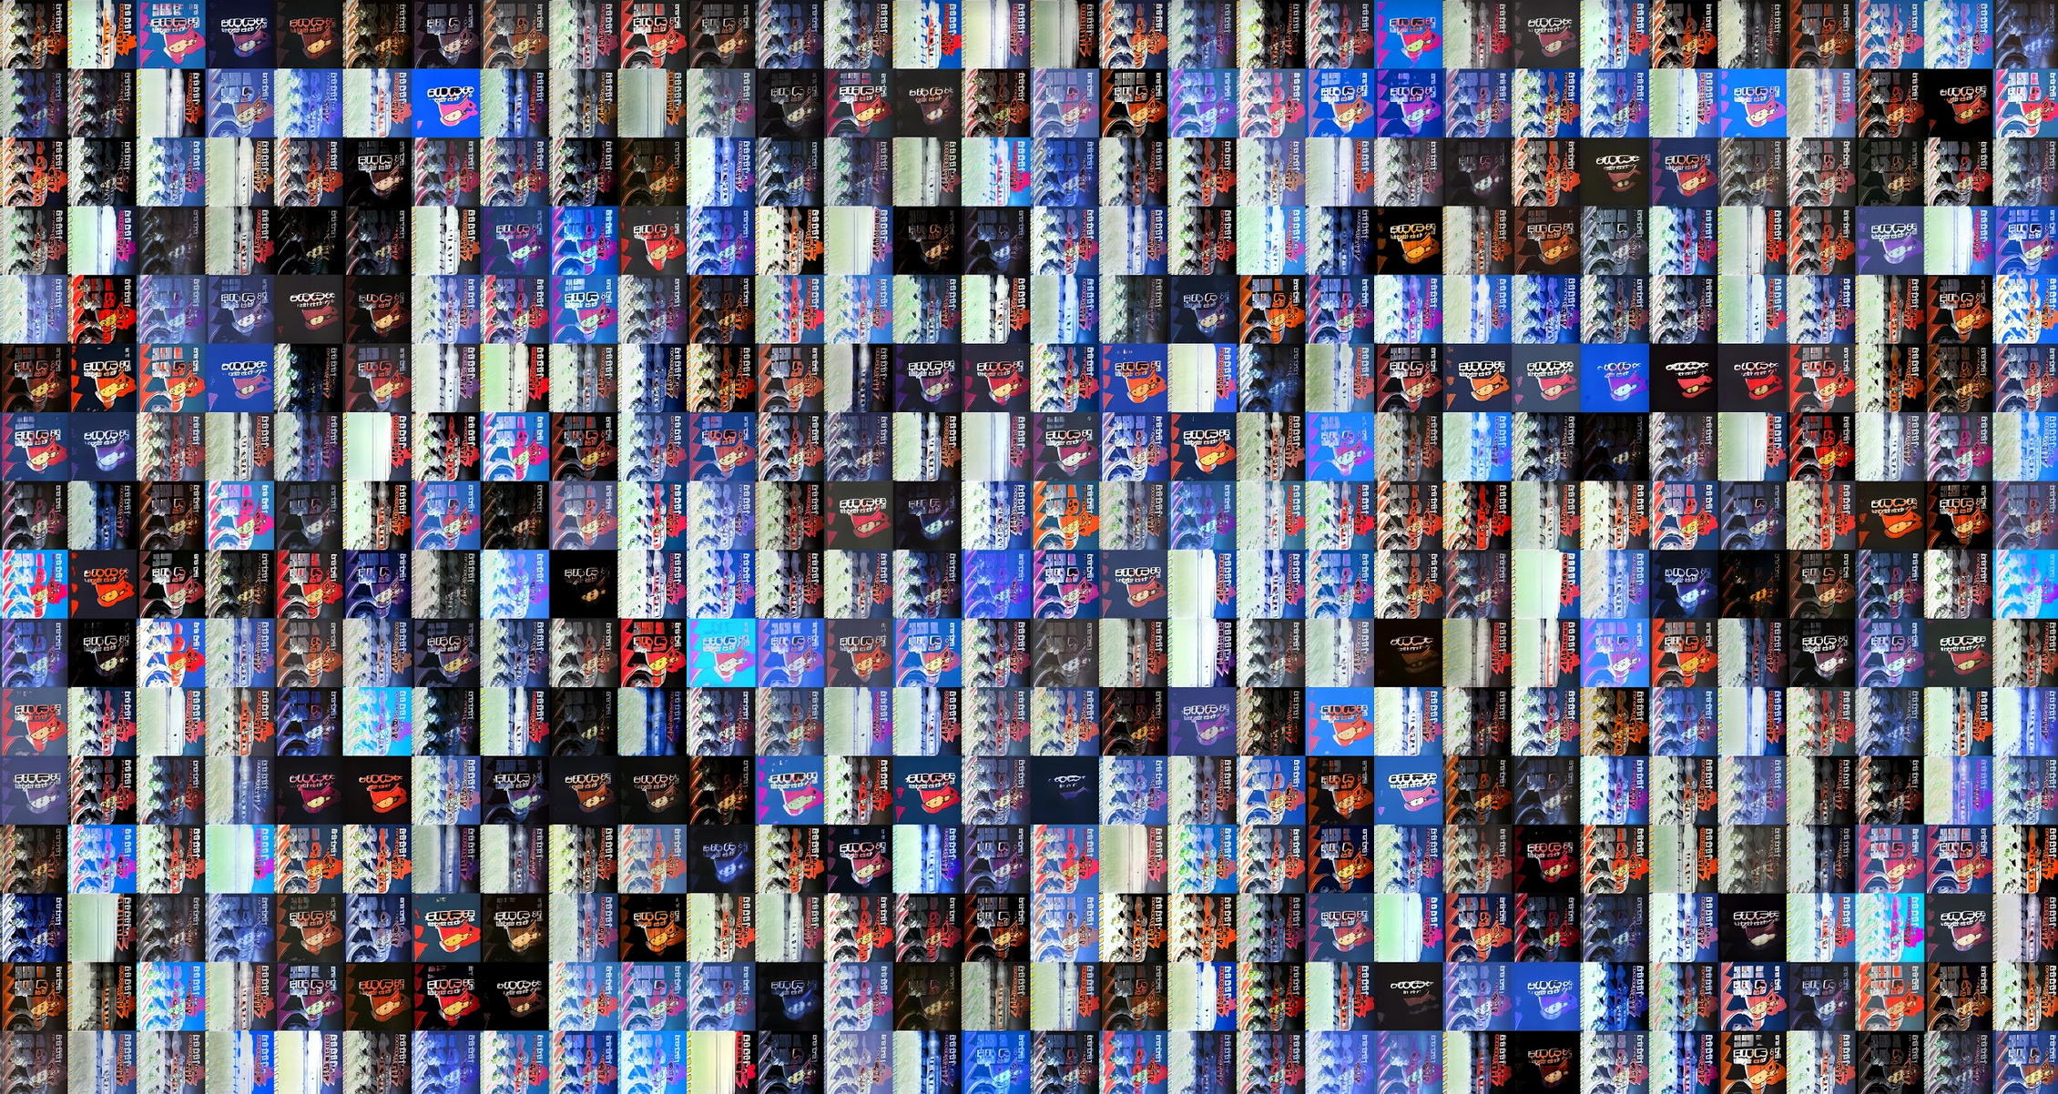
* I would consider this attempt to be a success and so from now on i will be working on how to do this on your own database

## Tues 16th

* I would like to spend today preparing my own version of woctezumas notebook, involving my image padding stages
* I would also like my notebook to intake a .zip file rather than a .tar file which should be quite achievable
* Uploaded the zip of the cats + dogs to google colab
* Figured out the unzip command and got it to add the unzipped files to the virtual machines storage
* Going to only work with the cat images for now and see if i can get it to ‘make its own cat’
* Been working on getting my image resizing + padding working on my google colab notebook
* After a while spent looking over a silly error with John we realised that not having a “/” at the end of the file path was somehow making the files not findable but thats resolved now
* Images are now being successfully padded on the virtual machine
* Going to now try convert the images on google colab to .tfrecords, feels like i’m making good progress here now it’s quite nice
* SUCCESS
* .tfrecords of the cat images have been made, now i just have to train this. HOWEVER i need to figure out how to make sure my google colab doesn’t disconnect
* Colab disconnected before i had time to upload the dataset

## Wed 17th

* Really want to get the dataset of the cats uploaded to drive, attempted it once this morning and i ran out of space then the vm disconnected
* Going to reattempt some of the stack overflow solutions
* Tfrecords are quite a large file size so i may need to upgrade drive space from 15gb, especially when i have to start saving my trained networks too
* 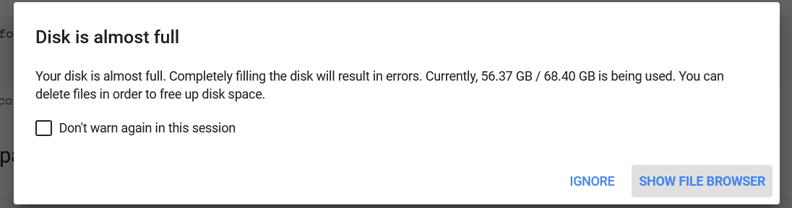
* Colab also getting concerningly full

## Meeting notes

* In blog post convey what ive found out + how can i make it not require weeks and weeks just to make some code run
* What could i provide to someone that means i can easily give someone my knowledge
* How could this be made more straightforward, what is the standard format that GANs would be in
* “What could you say to yourself to help you understand this”
* Need to cut down size of dataset
* I have changed dataset to 3k dog images rather than 12.5k cat images
* Have set up and uploaded the tf records for these images
* Going to now leave this to run in the background and train, thankfully this work is automatically uploaded to drive
* It is recommended by the notebook to use ‘lsundog256’ because it is a diverse pretrained model so i will try it for now
* ValueError: Cannot feed value of shape (3, 3, 512, 256) for Tensor 'G_synthesis/64x64/Conv0_up/weight/new_value:0', which has shape '(3, 3, 512, 512)'
* Realised i was being silly, it needs a network pretrained on 512x512 images not 256, going to use ffhq512 just because it was the only recommended one for this resolution, i can experiment more in the future

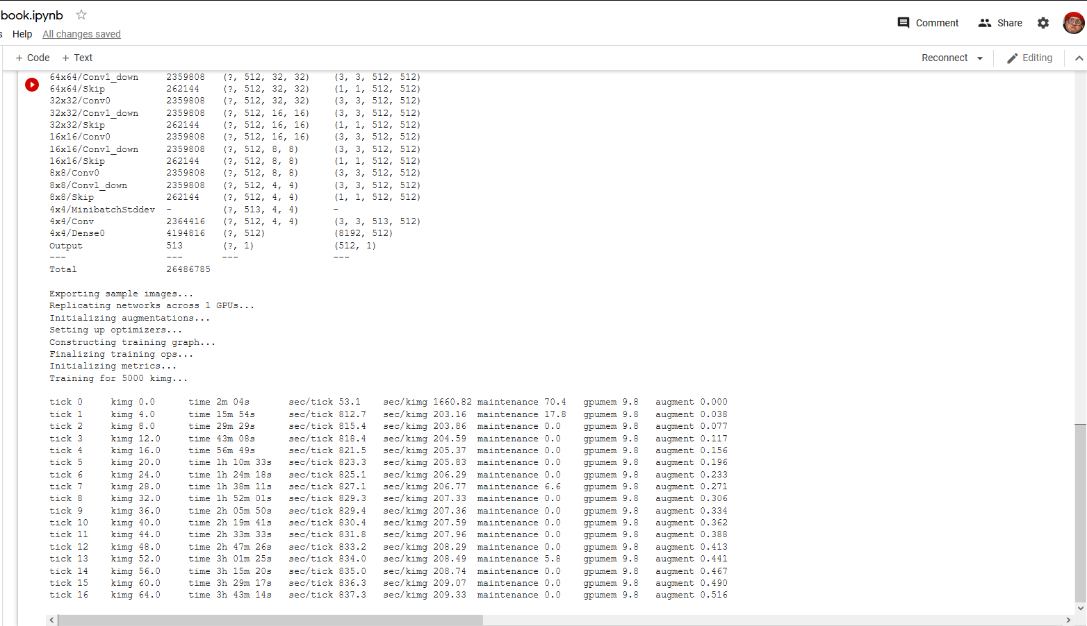

* Ended on this and disconnected, i believe it completed training

## Thurs 18th

* 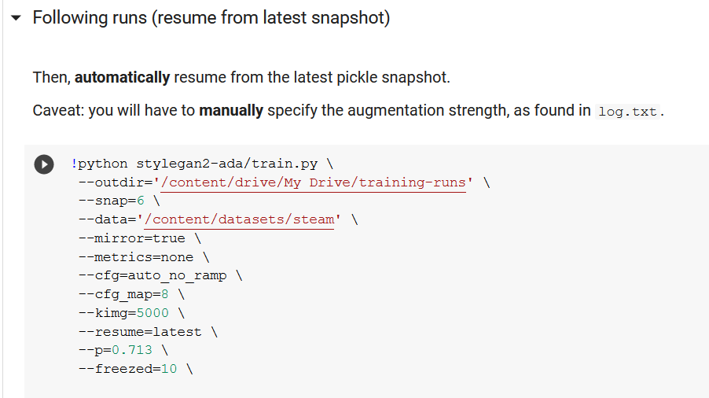
* Need to run again using following runs, it is set to resume = latest
* I have also looked into it and i have realised that the ffhq512 pretrained model was trained on the flickr faces dataset, so hopefully this helps my network to create its own dogs
* 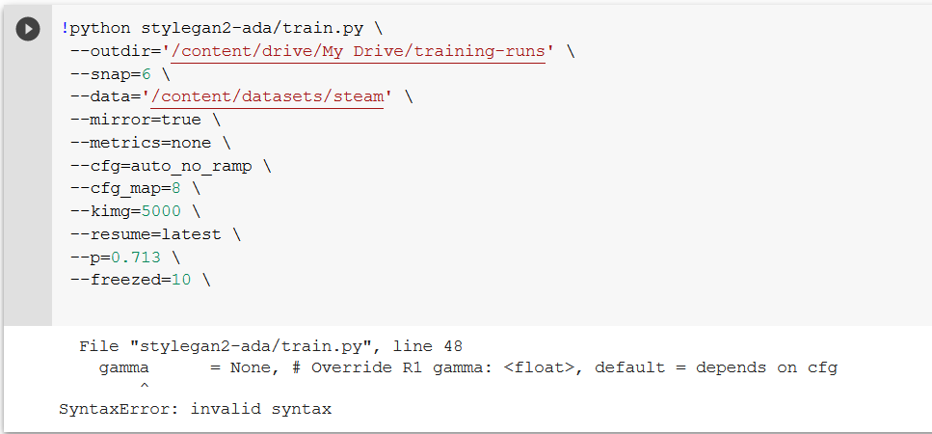
* Receiving the same gamma error, very strange, seems im going to have to fix this every time i go to use train.py
* 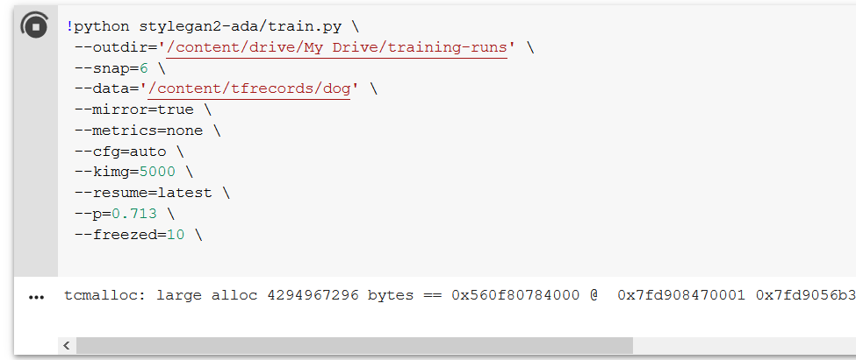
* Not sure how exactly this should work, im assuming that i reuse the same dataset

## Fri 19th

* Took today off to revise for my csc 1023 databases test on monday the 22nd

# Week 6 (21st Feb - 28th)

## Mon 22nd

* My databases test was today so i spent my time with it

## Tues 23rd

* Had surgery today so my day was taken up by that (nothing serious)

## Wed 24th

* Going to make up for lasts weeks lack of progress in the next week
* I have had quite a major lack of progress this week and the blog post is (i believe) next friday
* Can’t access canvas to check for some reason
* From the work on wednesday last week i have a couple of drive folders with: pkl snapshots, logs, training_options.json and a few fakes that it has generated, a couple of these fakes look like they could be getting somewhere
* For example here you can see what looks like a quite terrifying human (from transfer learning) and dog (from dataset) combo
* 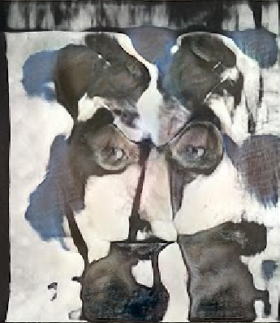
* And this other image to me looks like the outline of a dog
* 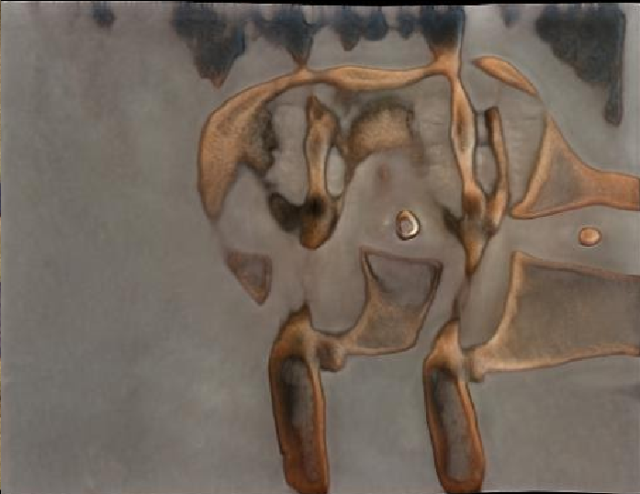
* These images are from the initial run and in the next week hopefully i can refine the network to produce more realistic dogs

### Meeting Notes

* Main difference between how to and blog post is that in how to you have to sell your works (e.g showing results at start, making sure this is something someone can follow)
* Blog post more about longer term objective of the project
* Lots of screenshots
* Longer term objective - Producing image of someone based on characteristics in life simulation program
* Current priority - Fully working stylegan
* Major priority is providing accessibility for stylegan
* Time split: focus more heavily on blog post
* Diary is most important + communication about what im doing and why
* Blog post next important
* Just after is github repository
* I also need a section on using colab + its limitations

## Thurs 25th

* As per John's advice i would like to start working on blog post, how to and my github repository
* So far i believe that my github repository simply needs my notebook and maybe a mini guide
* Need Johns help on getting rid of the strange syntax error around the word gamma, where i have to reupload the train.py file due to a missing comma that should be there
* Also discussed adding a piece by piece description of the notebook and agreed with John that it should be in the how to guide,
* He also mentioned that there can be significant overlap between the how to guide and blog post
* Going to try importing my own train.py after importing the full stylegan repository
* Here is how i have edited the code so far to test this:
* 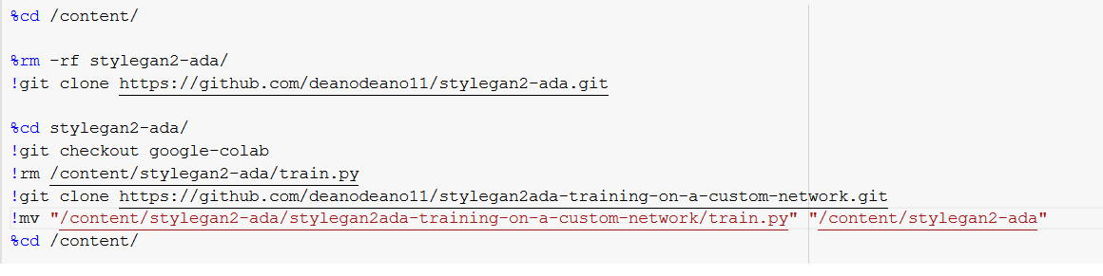
* Essentially i import stylegan2-ada, delete train.py, import my own train.py then move it to where train.py was previously
* This appears to have fixed the error
* seems like a clunky solution but hey if its stupid and it works then it aint stupid
* Now that i have that solved i would like to get more training runs going but im not sure how to get them to follow on from previous snapshots

## Fri 26th

* I believe the next logical step for me is to go through train.py file and document it, to help me explore the label functionality and to understand the process better
* 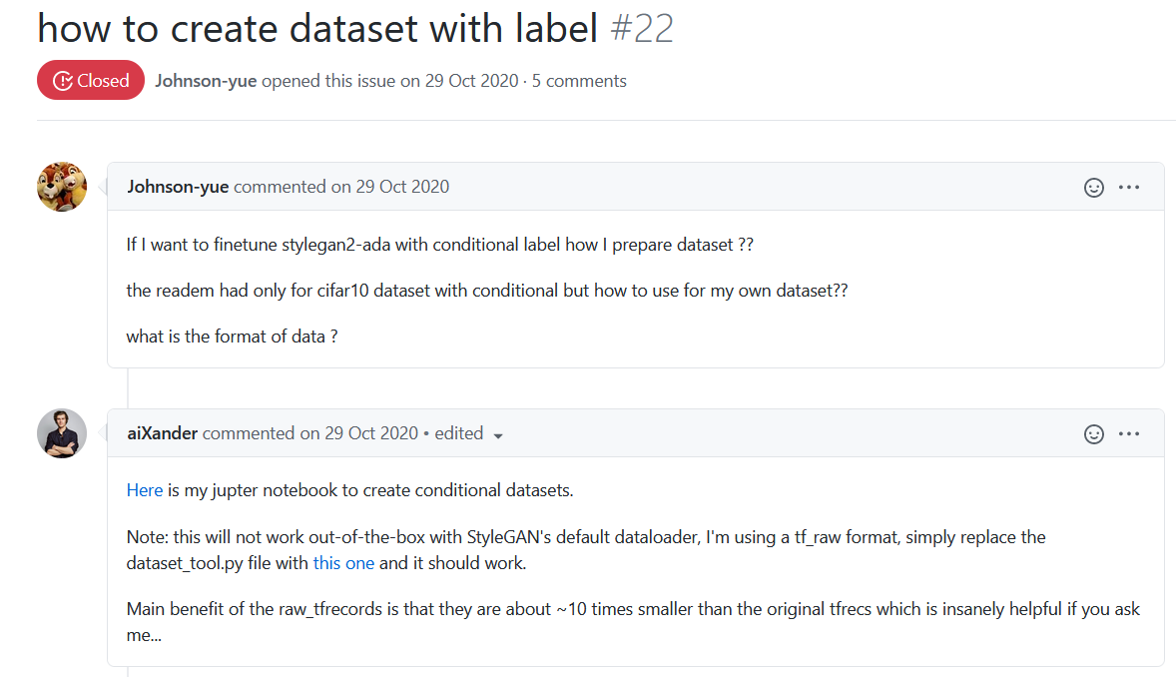
* Read through this thread however the user aiXander’s links would not work for me and i therefore could not make use of this
* Also read through this document <https://towardsdatascience.com/tfrecords-explained-24b8f2133282>

# Week 7 (28th Feb - 7th March)

## Mon 1st

* Deadline for Github page, how to guide and blog post is Friday and this will involve alot of work, so from now on i shall shift my focus
* We are also moving into crunch time, going to have 3 assessed pieces of coursework going on at once
* Started the day with good intentions however realised i’m quite behind in our web technologies group coursework so having to spend my time on it
* Currently for my work i also am in the situation where i know what i have to do but i’m not sure where to start it (e.g blog post, guide or github) and i think i’m using that as an excuse not to, have to get it done soon.

## Tues 2nd

* Spent all of today working on my web technologies coursework

## Wed 3rd

* Next few days are going to require alot more work, today i aim to get the adjustment of the how to guide done and do some work on the blog post

### Meeting Notes

* Make blog post as concise as possible, enabling someone to run and then build upon your work, within 1 week
* Page limit is simply what a student is willing to read
* Also need to talk about where we could go next
* Best way is to use alot of visuals and have it step by step, not in text book style
* Basically best way of showing the blog post works and therefore to get marks for it is to show it to someone who doesn’t know what it is (in my case nathan)
* Therefore me and nathan will be exchanging and reviewing eachothers blog posts
* Emailed xander about his labelling system as it was for stylegan2 but the links were no longer working
* Also changing my focus from earlier as i was going to prioritise how to guide adjustment but i think i should focus on blog post so that i can give nathan time to read over it
* So i need to figure out how i want to lay this out, from a very high level there are two aspects, getting up to speed with where i am now, and then where the project could go in the long term
* I think in the blog post it would be a similar layout to the how to guide in that i still need to talk about finding the dataset, preparing the dataset, converting to tfrecords then training
* I have come up with a first draft of a potential table of contents: 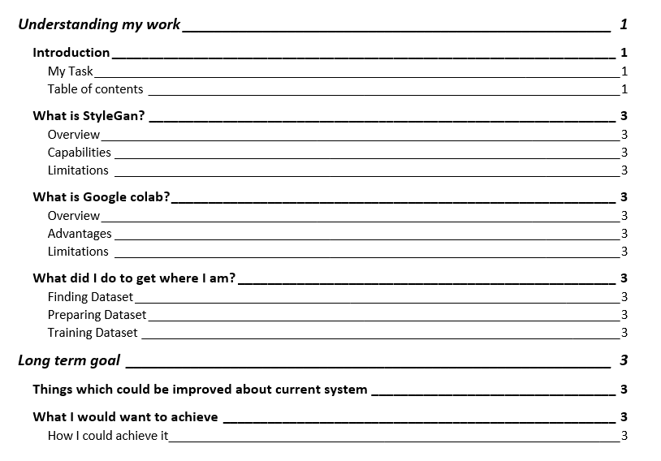
* Which i will be sending to John to see if he has any thoughts or comments before i get into actually filling out the post. In my opinion when undertaking things like this it’s much nicer to have a structure layed out before starting
* He advised me to change it from “my” to “the” project
* And also said that the how to guide and blog post can reference eachother
* He also commented that this current table of contents seems “Reasonable” and that seems like a good start to me
* As a personal note: When i go to improve the how to guide i need to change the contents to be in the form of referring to the colab notebook, and also add the wacky hybrid dog human images as something to grab the readers attention

## Thurs 4th

* Today i am aiming to get a very large proportion of, if not all of my blog post done
* So it can be reviewed by nathan
* I am going to start by running over my understanding of what styleGAN is and really help to take the reader from basics
* This involves me trying to use no complicated language and explain concepts well without need for any technical background
* I also fully understand that i am producing this for someone with the attention span of a student and so will try to break up the work as much as possible, avoid long paragraphs and enter plenty of images to keep them interested.
* I am typing alot of info about GAN’s and vectors and weightings and i’m not 100% sure if everything im saying is correct, may send it to John just to make sure im not too far out
* Also wasn’t sure on how working with github would happen as i was under the impression it was just for the actual project aspect and not all the documentation, but after clearing things up with John i’ve realised we should put the entire project on github in order to implement source control
* Have pushed everything to my github page, now going to continue working on blog post after some lunch
* Going to make the how to guides intro page more concise and instead make it point to the blog post if the reader wants more info, i think this is fitting as captivating the readers attention is more important in the how to guide
* Messaged John to check if my paragraphs on vectors and weights were actually correct and i dont think they were so im going to have to look over this
* Friends are talking in our group discord about the how to guide vs the blog post, it seems like they are more intending on the web guide being referenced by the blog post rather than the other way round
* I believe i should fully define what im doing in the blog post and why:
* So my first section ‘understanding the task’ is essentially a section on what i would have loved to have known starting this project myself, i would aim for it to kick start their understanding of the topic in a concise and understandable way.
* Firstly i am adding a section on StyleGAN, running over what it is and its capabilities, then how it is relevant to the task at hand, so that the student can better understand what theyre working with
* Secondly i believe this section also requires an explanation on colab, as while i see it as quite simple and easy to use now, it was incredibly daunting at the start, i also aim to help the student understand what it is good for, but also its limitations due to time limits for connections etc
* Thirdly i want a section on where i am at now, so they know their starting point, i dont want to go into too much detail as how i got here is covered in the web guide, so i will give a brief overview and then tell the student to look at the web guide for more info.
* I’m going to make a section called “understanding how to use colab and stylegan together” then point them towards my heavily annotated colab notebook as an example. As i believe learning from example works well when there is good explanations attached to the example.
* Then the second major section of the blog post would be my long term goal
* So after i have gotten the student up to speed and understanding the work done so far, i will then tell them where i want this to go.
* I want to talk about labelling and provide links to articles i think would be useful for this
* I also want to tell them about how this could be used practically
* For example one of the other projects is ‘life simulation’ and in this the life of a person is simulated, and many characteristics about them are produced.
* We could use the trained GAN and their characteristics to produce an image of what this person may look like
* Came up with what i think is a better paragraph on how my work links to the initial task, sent it to John for review
* I’m looking over Barry Cheevers’ blog post a good bit to gain inspiration
* Having difficulty coming up with detail to add to the long term goal, which i need to do as i know this is a key part of the blog post
* I also need to talk to John as i'm not sure if i can have multiple potential ways someone could further the project or i can only have one.
* Messaging Nathan and we’re going to talk about eachothers projects in the blog post
* Really struggling to come up with things to fill the section on where the project could be taken
* Which is quite annoying as i wanted to get the project fully completed today
* Going to go through and annotate my notebook now, ensure that it is as understandable as possible
* Sent my blog post to Nathan for some feedback and he sent me his
* I’m going to leave some of woctezumas comments in the notebook as they explain things very well and they don’t need changed, however i am editing out his talk about the steam banners of course
* Im also adding my own parts to woctezumas work to make it more understandable by a beginner
* Woctezuma only pointed to a stackoverflow page on keeping the notebook connected, im going to insert practical advice and exactly how i did it

## Fri 5th

* Deadline is tonight, as of right now i need to finish notebook annotation, do more on the future section in my blog post, and adjust my web guide
* Finished off my notebook annotation. Still no response from John with regards to whether i should talk about multiple directions the project could be talked about or just one.
* Going to work on the web guide instead
* I’m changing a few parts of my web guide to talk about something briefly but point to the blog post for more information, eg for stylegan and colab this is for two reasons:
  + The user reading the how to guide could very well already have a good grasp on these things and therefore not need the extra information. But the option of extra information is still there.
  + Even if the user wants to follow the how to guide they don’t really need to know things such as “the advantages of StyleGAN2-ada over StyleGAN2”
* I will still keep in the useful links at the left hand side of the page in the how to guide as it could still be useful
* Removing content on labels + training/validation sets as it simply isnt relevant to get to the stage i am at, however it should be useful later on, i may add it back in for the next hand in date
* All conversion to .tf records info needs changed, this time round i actually got it working which is nice.
* There is a reasonable amount of crossover between the colab annotation and the how to guide but i think this is fine as the guide presents it in a nicer way and talks the reader through it more clearly
* Finished working through how to guide and fixing it
* Now i simply need to complete the blog post, i’m not sure if John noticed my question about the long term goals but i talked to my friend on the course and we agreed it would make sense to talk about multiple directions in which your project could be taken
* Going to add further info on tfrecords and transfer learning to help a new student better understand why i have done the things i did
* I have also added a character sheet from the fallout series as an example as i believe it more accurately shows what we would be wanting to show rather than the classic dnd character sheet
* Going to talk about life simulation as a potential project to integrate with as it is very interesting to me
* I believe i have talked enough about future plans so im going to go over nathans feedback
* 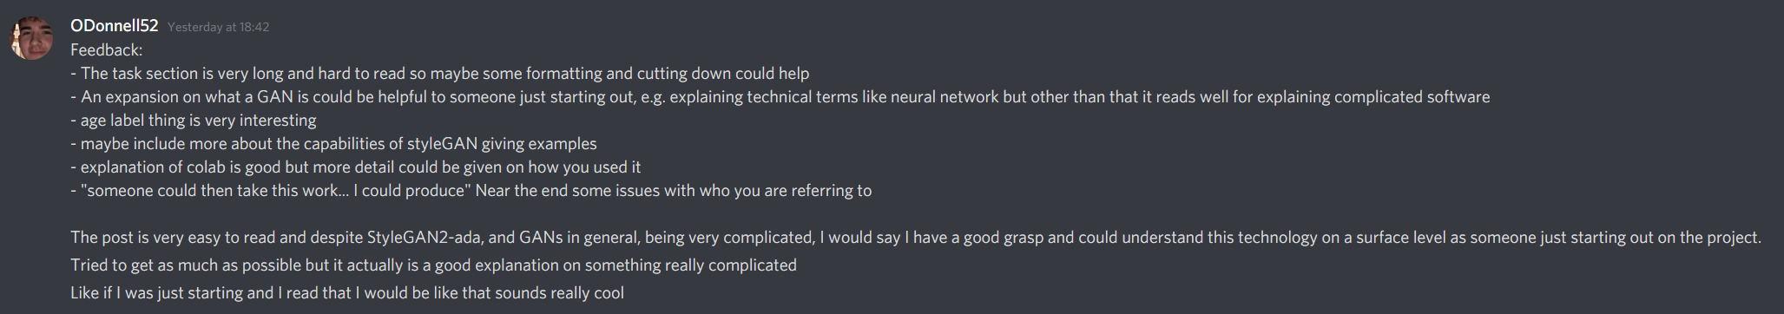
* I will go through this point by point
* “The task section is very long and hard to read so maybe some formatting and cutting down could help”
* Couldn’t agree with this point more, i simply copied and pasted the prompt from canvas but then saw that Nathan had his nicely formatted and in a much more concise manner, going to fix this now
* “An expansion on what a GAN is could be helpful to someone just starting out, e.g. explaining technical terms like neural network but other than that it reads well for explaining complicated software”
* This is a very fair point, i’m going to add a small glossary section to help potential new students with understanding the terms used
* “Age label thing is very interesting”
* Couldn't agree more, that sort of thing is what made me want to do this project
* “Maybe include more about the capabilities of styleGAN giving examples”
* A good point, i will actually link to <https://thispersondoesnotexist.com/> to demonstrate this.
* “Explanation of colab is good but more detail could be given on how you used it “
* Another good point, i will add a section on how i specifically used it
* “ "someone could then take this work... I could produce" Near the end some issues with who you are referring to”
* I have fixed this issue
* Going through definitions, double checking with John that everything im saying is correct, I also am adding links to each definition but cannot find any articles on GAN encoders. I suppose this is an issue when working in such a young field.
* I have near enough finalised my work
* Going to try add some useful links for continuing the project to finish off the blog post
* I now just need to fill my github repository with all the needed files, going to add a copy of my notebook too just incase the link stops working
* Everything has been finalised, including github repo, now just need to upload this on canvas
* Before i do this i’m going to ensure i have fixed issues from last upload of how to guide
* Main issues last time were:
* That i wasn’t sure if what i was saying would work, which i am now
* Only part of my project was being done on colab, it all is now
* Should have an illustration to show ‘magic of the algorithm’ which i now have
* I also would like to further justify what i have done and learnt from to make my how to guide as effective as possible.
* My understanding of the work has been the culmination of many youtube videos and articles, then once I felt I had gained understanding I went to John to ensure my understanding was correct. E.g sending him my simplified definitions and him telling me if something was wrong.
* This way I not only gained understanding, but also then reinforced it, and in cases where I was wrong, fixed my mistake.
* Once i had done this i tried to present how i, as a student, understood these concepts.
* I believe this is the most effective way of sharing my knowledge to a student who is looking to pick up my project.
* I was ensured that this approach is effective when Nathan got back to me and said “The post is very easy to read despite StyleGAN2-ada, and GANs in general, being very complicated”
* The assignment outline also says to add screenshots, i added some images to keep things interesting, however i didn’t want to put in lots of colab screenshots as instead i heavily annotated it, then provided the link to the notebook and encouraged the reader to have a look for themselves. I believe lots of colab screenshots would have been unnecessary.

# Week 8 (7th March - 14th)

## Monday 8th

* Put aside my other coursework responsibilities for this module leading up to the deadline so i’m now going to spend time on them
* Spent today on web technologies coursework

## Tuesday 9th

* Spent today on web technologies coursework

## Wed 10th

### Meeting Notes

* Make a notebook that takes in trained gan and takes in vector and produces a picture
* Stage before labels - being able to take a picture and estimate vector associated with it
* Valuable addition - Annotating train.py
* Look for encoding code
* Could just make my how to guide be my notebook
* Might want to embed the notebook text, take excerpts of it and put it in notebook
* “Note that youll have to manually specify log.txt …” fix
* Explain more of the notebook, do searching + investigating for encoding code

## Thurs 11th

* Continuing work on other coursework projects

## Fri 12th

* Still haven’t gotten caught up on other modules to a stage I am happy with. Going to back to more 1028 work on monday

# Week 9 (March 14th - 21st)

## Mon 15th

* Looking into the “Note that you’ll have to manually specify log.txt …” note and i have found the log.txt file, but cant seem to find anything on what the augmentation strength should be set to
* I have found that after each tick the augmentation strength is given, so i’m presuming the provided aug should be the aug of the final tick
* 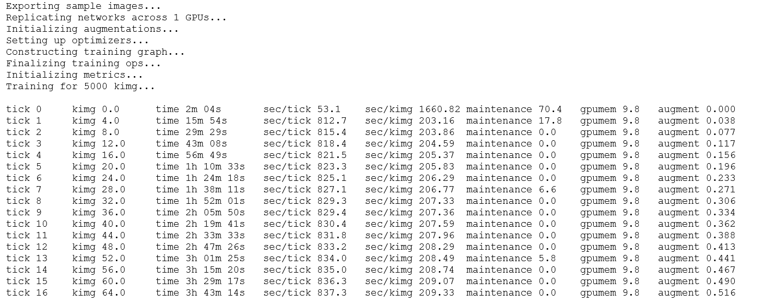
* In this case 0.516
* I also need to sort the case of how to resume from the previous snapshot, as right now it is simply set to --resume = latest, but latest wont be set after leaving and reconnecting to the virtual machine
* 
* Found this under the github page and i believe i point it to the most recent pickle file produced
* I’m not sure if i should reuse the same dataset or if i need more to redo the process with more images
* Asked John and he said that it simply runs over the same dataset
* Going to rerun the program and train my .pkl further
* Firstly adding notes on augment and resuming so that users reading my guide can easily complete this step
* Going to run this further training, this will probably take me until the end of my working day

## Tues 16th

* The network continued training for about another 4 hours last night
* Once again the images produced were somewhat dog like and quite terrifying

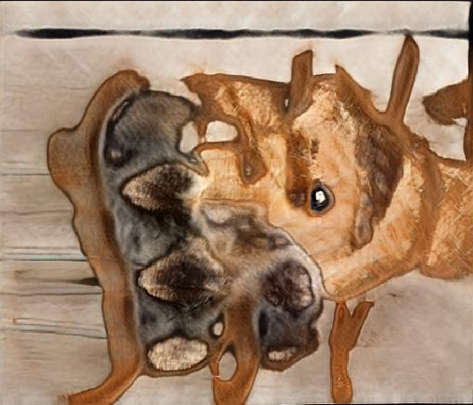

* I would like to attempt to take a picture and estimate a vector based on the image
* This wont actually be possible right now as i cant connect to the gpu backend of colab as it is under heavy use
* Going to work on my web technologies coursework instead

## Wed 17th

* Going to take the day off as it is st patricks day

## Thurs 18th

* Same situation with not being able to connect to gpu in colab
* Will do more web technologies coursework

## Fri 19th

* Connecting to gpu in colab well now
* After looking at it more im not even sure if this notebook does more than train the network further, i would have assumed it was for usage of the pkl
* I see now i was on the Custom_Training notebook while there is a more relevant image_sampling notebook
* Trying to create my average image of the dataset however getting an assertion error
* According to stack overflow pages this means it is due to programmer error
* 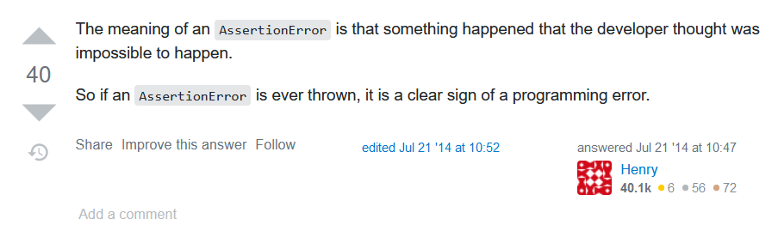
* Going to message John to see how best to proceed, as i think making the average image could be very interesting
* I need to get the vector that was used to create the image and enter this on that line, however i have no idea what this is or how to check it
* John wants me to look into train.py, find the code which produces sample images and modify it to print out debug info and make images
* I’m looking through train.py but having real difficulty with finding information on how the fakes are produced
* John has recommended i try running generate.py to create new images
* Managed to get generate.py working after talking it through with John
* I would like to actually train my network further so i’m going to get that going now
* Nevermind can’t connect to gpu backend again

# Week 12 (March 21st - 28th)

## Mon 22nd

* I think documenting train.py line by line would be very helpful so i have messaged john about doing this on wednesday
* Going to produce more images, going to try with and without truncation
* The dog images are okay but i think it needs further training
* This was using generate.py to create images
* I will now attempt to use Style mixing in style_mixing.py
* I found this as it is another section in woctezumas image_sampling notebook
* Looking into what John said it seems that i could edit generate.py to take in a custom vector, however i would like for the images produced to be of better quality first so im going to train the network further

## Tues 23rd

* Spending today working on web tech coursework

## Wed 24th

### Meeting today

* Allow to specify z or noise_values or not depending on what the user wants, if they dont specify randomise it
* Testing format:
  + Not specified
  + Ideally something that the next person following along can rerun
  + Convincing to the student/john that it is working
  + Showing you have considered ways in which it can go wrong
* Could do with another dataset as a test case
* Put .labels files inside the file with the images
* Labels need to be numpy array
* In creating tfrecords for images it specifies them in a particular order
* Look into stargan-v2 to potentially find info on labels

## Thurs 25th

* Spend day on databases coursework

## Fri 26th

* Spent day on web technologies coursework

# Week 13 (March 28th - April 4th)

## Mon 29th

* I’ve had quite a lack of progress recently which i’m not very happy about, i think that the pandemic and not being there in person creates less of a sense of pressure to do work and therefore i don’t feel the need to do it as much as i normally would have.
* That being said i’m going to try step up my progress soon as the deadline is coming up now
* I’ve mapped out my deadlines for all of the modules:
* CSC 1023 Databases - 19th April
* CSC 1028 Challenges - 23rd April
* CSC 1030 Web Tech - 26th April
* Theyre all quite close together but at least there is a few days between them, need to be making my progress now.
* Today i would like to produce images using vectors via the .py file we found (means i thankfully dont have to go and make my own version of generator.py
* Ran projection.py on my image and produced a video file and this projection
* 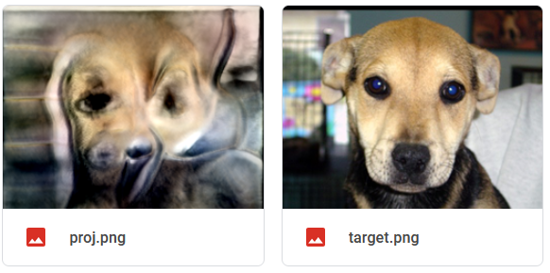
* Not entirely sure on what this was actually trying to do, I think it produced vectors based on the image then tried to recreate it using the vectors?

## Tues 30th

* Showed john projection work using my network
* He suggested trying it wit fffhq512
* This is very easy to do as the pkl is built into stylegan
* 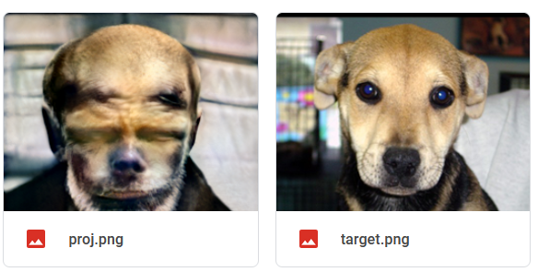
* Attempt with ffhq was quite scary looking also, but as john pointed out it lined up the mouth and nose correctly and wasn’t a terrible attempt
* Just for fun im also going to try putting my own face in
* John has explained what the network is doing when running projection.py he has said “The projector is adjusting the vector (probably starting with a vector of all zeros or something random) such that the image that is produces becomes more like the input image. Because the image generating network can be differentiated it can tell how different small changes to the input vector will create small changes in the image so the system can calculate the difference between the current generated image and the target and use the differentiation to work out small changes to make to the vector to reduce the difference between the images. Once the vector is changed a bit the 'gradient' will be different so it has to loop around making small adjustments and gradually reducing the difference in the image until no change makes a significant difference.”
* So my simplified understanding of that is that the system produces a random image, then checks how different this is to the target images, then adjusts the vector of the image each time to reduce the differences between the images. It does this repeatedly until each loop of this adjusting makes very little difference to the image itself

## Wed 31st

* Considering what i should be doing from now until the deadline of the 23rd, i have 3 weeks at least one of which should be brushing everything up and producing testing etc. However i also have other coursework subjects which have deadlines near this time so i may want to try and be done for an earlier date
* That being said i would really like to produce a network trained with label data
* I’m going to shoot john a message to see what he thinks

## Thurs 1st

* John has given me a list of potential things to do
* He pointed out that the main priority is saving time for the next person who comes along
* I’m tempted to maybe make a bunch of separate notebooks to do each of the following things which he suggested:
* Use the pretrained models to generate an image from a vector (and be able to adjust the initialisation and understand any parameters)
* Project an image into the model to get the closest vector (and be able to adjust the initialisation and understand any parameters)
* Train a stylegan-ada model with their own images Making this as easy as possible with screenshots and code that can be easily run is the most valuable thing initially. Also be sure to go into as much detail as you can about the code, explaining the lines if possible so that the person coming along after can try to understand the process. It may be a good idea to read the paper and look up some of the commands to find out what they mean.
* The step after that is exploring the labels. Investigate how to train a model with labels and how to generate images with labels. First follow the instructions to download a dataset with labels and see how they are specified. Possibly try to train one of these examples to check the code works ok then try to train one yourself.
* However i don’t think that individually making a notebook for each of these would be feasible given the time constraints and work in other modules i have going on
* I think the best thing i could do would be to try and implement as much of this as possible on one notebook.
* Asking John how i could go about generating an image from a vector and vice versa.
* In order to generate using a vector i’m going to need to augment the code in generate.py as we talked over in our meeting together, this is still a very scary proposition to me but i will give it my best shot.
* So i need to “Allow to specify z or noise_values or not depending on what the user wants, if they dont specify randomise it”
* I dont even know where to start editing code here or if i should just make my own
* Going to put in some random print statements
* Printing out noise_vars now to find out their format

## Fri 2nd

* Going to work on at web tech work today, still have a few weeks left on deadlines but theyre getting scary

# Week 14 (April 4th - 11th)

## Mon 5th

* Slight change of plans
* My csc 1023 databases coursework is quite boring and will take a while and so i have done very little of it
* I am going to do my best to get it done as fast as possible so that i only have to worry about my web tech and 1028 coursework
* Spent about 6hrs today on it solid

## Tues 6th

* Completing csc 1023 coursework

## Wed 7th

* Underestimated the time that 1023 coursework would take, still working at it
* Got it (pretty much) completed thankfully

## Thurs 8th

* Taking another stab at augmenting generate .py, it’s very difficult to work with
* Attempted to send the data to a csv file via numpy but it then supposedly wasnt in the correct format
* Messaged john about this

## Fri 9th

* Feeling very overwhelmed by my workload and trying to understand how to augment this code, i think a call would work alot better for explaining this as i feel a good amount needs done and it is tougher to convey things via messaging

# Week 15 (April 11th - 18th)

## Monday 12th

* Had a call with John to figure out how to approach my solution, i need to:
* Basically keep the code as it is
* And then with the generate function, you can have an optional dictionary that you pass in (json)
* the names are in the form: tf.Variable 'G_synthesis_1/noise0:0
* loop through the dict after noise_vars is generated and overwrite
* we would wanna be able to pass it in
* {var: rnd.randn(*var.shape.as_list()) for var in noise_vars} store in variable then modify it
* When we finish the function we want it to return the dictionary of resolution noise initialisation (AND SAVE IT OUT)
* Do this same process after for the z vectors
* I also made these comments

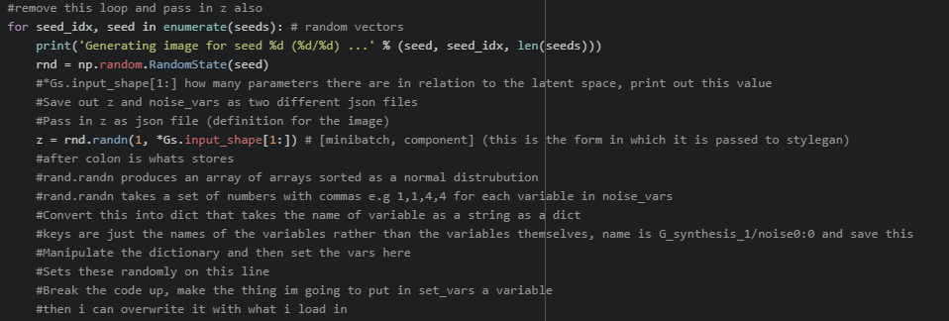

## Tues 13th

* Going to work towards practically implementing this
* First things first i need to change tflib.set_vars to be using a variable rather than everything being done on one line as they love to do



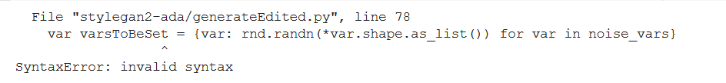

* Bad start, not sure what is causing this
* Nevermind i just forgot how python worked
* Removed the var word and it works now
* Now that i have done this i would like to dump the noise vars dictionary to a json file,
* I’ve never worked with jsons/dictionaries before



* Going to reattempt a json dump of the dictionary
* “TypeError: Object of type RefVariable is not JSON serializable”
* Messaged john about this
* Tf.variables are the keys that cant be converted to json, i will have to create a new dictionary myself
* This is proving alot more difficult than expected since i really am not sure on how to work with dictionaries
* It seems there may be built in saving functionality which i would like to try and use as utilising json seems unnatural and like alot of hassle
* Nevermind messaged john about this option and it wont do what we need, going back to reattempting json work
* Json doesnt want to save the variable.shape but i just need to get it in the right form

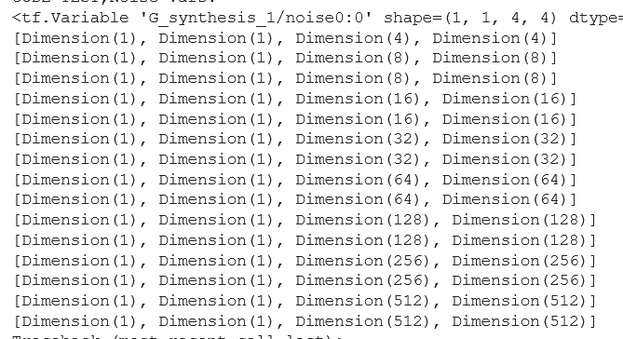

* Tfvariable.shape.dims is in this form
* Going to now check tfvariable.shape

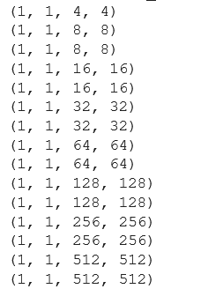

* It seems significantly more workable with, but json didnt want to save it, i can maybe manually extract them
* Very strange, in the documentation it says that tfvariable.shape.as_list gives a list of integers but i’m getting:

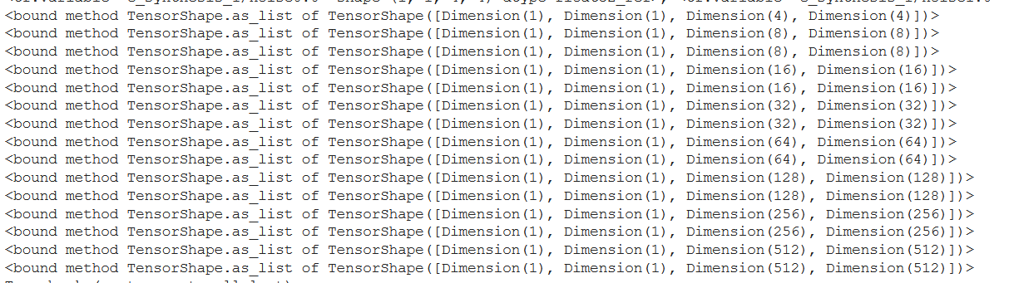

* Going to have more of a look at this tomorrow

## Wed 14th

* Going to continue to try to save dimensions
* Realised my issue was that i was typing tfvariable.shape.as_list rather than tfvariable.shape.as_list() as a method, the method now works as wanted and dumps to a json file
* Was absolutely ecstatic to see it working
* Now have to iterate through this json file and be able to load this back into my own noise_vars
* I made a custom write_json file to choose the file which it is saved to, this will be set to the output directory
* Having slight difficulties in reopening the json file, im also not sure where best it would be to store this on the colab machine, i suppose the user should be able to store it anywhere then give the path
* 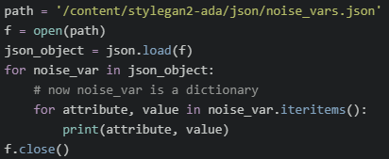
* Currently trying to print out the json values
* Cant seem to get this working, noise var doesnt seem to have an items property?
* Going to try just printing noise_var, on doing this G_synthesis_1/noise0:0 was printed, it seems the second loop maybe isnt needed

## 

## Thurs 15th

* Was my birthday so didn't do work today :)

## Fri 16th

* Spent the day doing work for my 1030 web tech coursework

# Week 16 (18th April - 25th (48hr Deadline extension)

## Monday 19th

* Major Crunch time now, very scary
* Need to hand in my 1023 databases coursework today so i'm going to work on finishing that up
* Really running in close to deadlines now, going to put in alot of effort over the next week

## Tuesday 20th

* Our CSC 1030 group has 4 people, 3 of the others are also doing 1028
* We are quite behind on the 1030 coursework and the deadline is 28th (including covid extension)
* Therefore we have decided to each dedicate up to and including saturday 24th for 1028 then after that committing ourselves to 1030
* So today i shall be continuing on with work on generate.py
* Spoke to John
* Actually realising that im saving out the wrong variable to json
* And it seems that this randomisation is based on the provided seeds, maybe i should remove these altogether? I will ask John
* He confirmed i can remove seed
* Going to just leave that file and write the code myself as its getting very messy, using original code for if it needs to be randomly generated then using my own code for loading in a json file if they provide one
* Quite awkward to work with, need to determine file type of z and varstobeset first
* It looks like z is made up of random floats with an exponent, separated by whitespace, potentially i could just convert these to a string
* 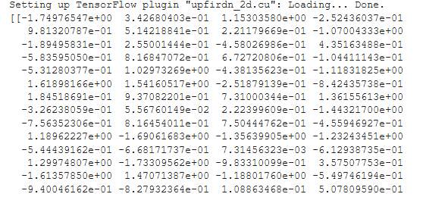
* Okay so i now know what VarsToBeSet and z look like, i need to save them to json
* However i believe i will need to nest the json variables as it is currently name : attribute while i need to store all of the random floats, however will ask john
* He believes i dont need to store the shape and need key : multidimensional array of floats
* I have now got this working, I’m producing json files 13.7mb in size which seems absolutely ridiculous but at least it does what i need it to
* I had saved out z variables as a json with the key being the count then the attribute being the item at that position in the list but john said it would be fine to just do the key as “z” then the attribute as the variable so ive changed it to that
* I now also have it saving out to google drive along with the image
* Now going to attempt work with parser
* Removed need for the user to enter either --seeds or --dlatents
* Now need to add my own method for providing path of jsons
* Going to look at documentation that John sent me
* Realised i can remove seeds and dlatents from input arguments as they aren’t relevant for what i’m trying to achieve, this has greatly simplified the code too.
* Colab disconnected and now it will only let me reconnect without gpu so i sadly cant make any more progress today

## Wed 21st

* Going to need to wrap up actual coding soon, today preferably
* Current goal is to now read in the json to varsToBeSet and the z variable
* Currently the user can input the path of the json files and this is given as a variable in code
* I need to then take this path, open the json file at that path, and then read this json back into the variables in the correct format
* Currently i am at the stage where i can print out the data of noiseVars.json provided
* Need to convert the list of numbers in the json back to a numpy array
* This is very handy actually because it would generally be hard for me to check that the loaded out varstobeset is in the correct form, but it actually needs to be in order for resaving it to not throw an error
* Messaged john showing what i did
* He instead suggested that i make the keys the values in the original noise_vars which makes much more sense rather than making my own tfvariables
* Sadly i cannot go and test this anymore today as all of the gpu’s are being used on colab
* And as you can see the packages cannot be loaded without it:

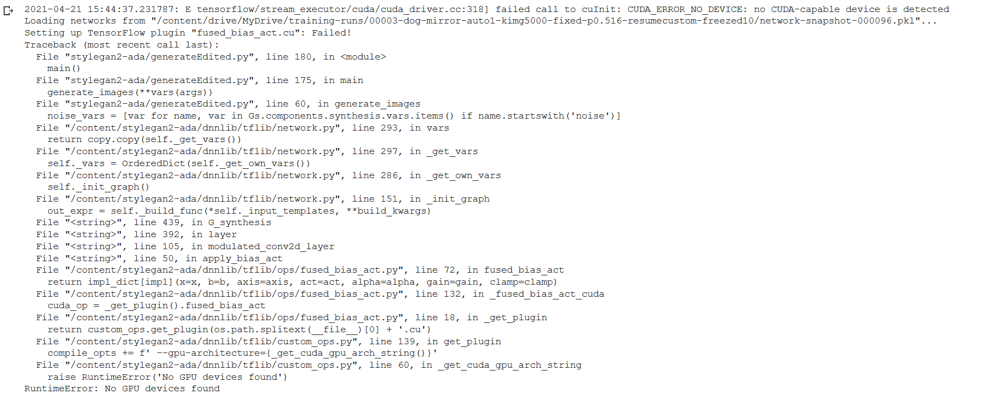

* I will instead switch to working on one of my other bits of coursework

## Thurs 22nd

* Got up today to do work at 10:16am and am still having issues connecting to gpu backend of colab, this is starting to become a real problem for me
* Attempting again at 2pm and it appears to be working fine
* I have worked through the code more and will now attempt to test whether or not it is replicated
* So first i will check do a run where the noisevars and zvariables are autogenerated and then i will do another run using the generated json files

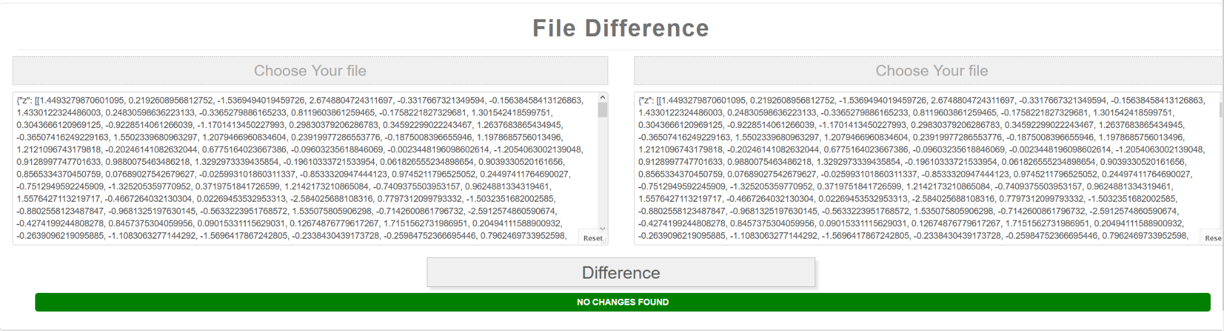

* Zvariables.json is the same
* 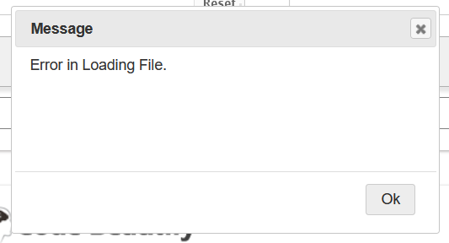
* The site isnt capable of opening the 17mb noisevars file, im going to see if i can download a tool to check it myself
* Downloaded the tool winmerge to check
* 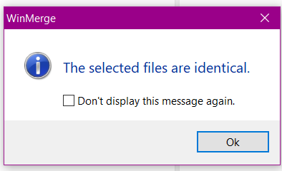
* And last but not least i shall check the image to see if the actual output is the same, i used the site: <https://online-image-comparison.com/result>
* It gave this output
* 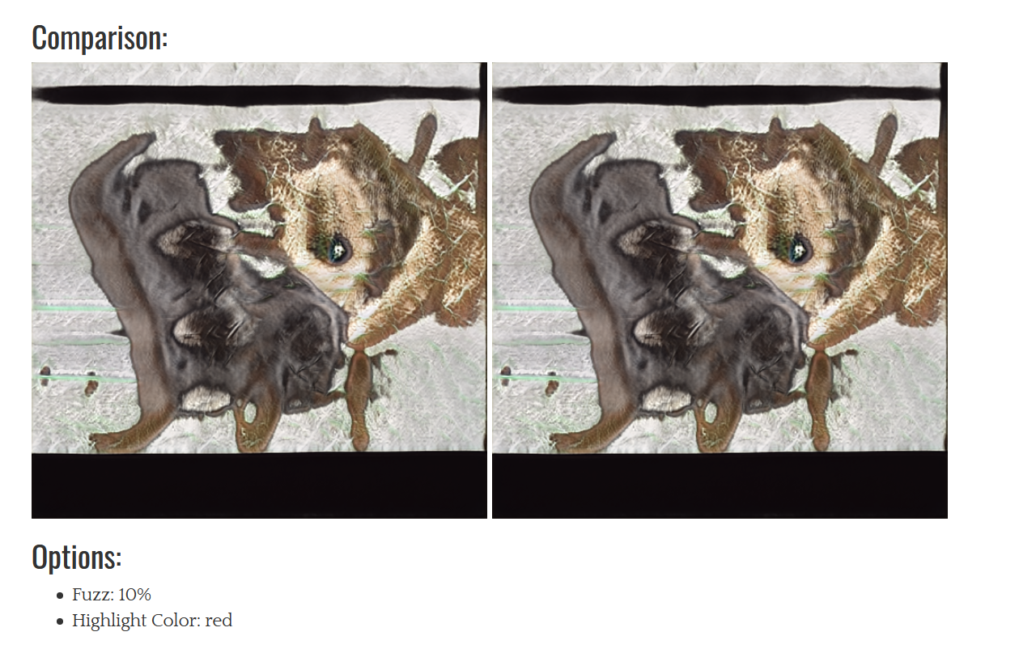
* And no red was shown on either image to highlight a difference therefore they must be identical
* I now have the rest of today, friday and saturday to work on writeup, this includes:
  + Making main how to guide be just a colab page
  + Potentially updating blog post
  + Making blog post an html page (easy export)
  + Performing tests on what i’ve written
  + Potentially a guide on how i went about editing generate.py to do what i wanted
  + An online post and or video showcasing my work
* Messaged john asking how he wants it formatted
* It seems it would be preferable if everything was on a single github page
* He also wants a downloaded version of my online google diary and colab pages
* Just spent a while editing the colab page so that it takes in the new github repo with all of my work so far and takes out the files it needs automatically

## Fri 23rd

* Need to switch my web guide from being a web page to simply being the colab notebook
* John also said i can do this with the blog post however i think an html page would be nicer
* So first thing is to move the web guide from being html to the colab page
* Have made steady progress on this
* Have to go out and clear my uni room today so i wont be able to do alot of work
* However im going to get the dataset that i will be using for my testing, i’ve decided to use a dataset of flowers i found on kaggle: <https://www.kaggle.com/spaics/hackathon-blossom-flower-classification>
* The original challenge was to determine what type of flower that the given image is however im going to pick one flower and try to get the program to generate it
* Im simply going to choose the flower with the most amount of sample images, this happens to be file 77 - passion flower. With 250 total images
* This isnt a large amount of images but it shall do, especially since i have time constraints, a smaller dataset can be uploaded, edited and trained on much faster

## Saturday 24th

* Took the day off work (regular job) as i really need to get this work done this weekend
* Spending my morning transferring the info from my web page to the notebook
* I’m also going to try and format the colab notebook in a nicer way
* Adding images to the colab page to make it a bit more lively too
* Taking a while but i think it is worth the effort, i'm up to transfer learning now in the switch over
* I have had the idea to use one of my dog images along with projector.py and the afhqdog pretrained network to try and get an attractive gif for the start of my blog post

## Sunday 25th

* I need to do quite a large amount of work today, including:
  + Add to blog post
  + Do Testing section
  + Social Media post
* That being said i think this is very achievable
* Started by adding an attractive dog projection gif to my blog post in order to make it more visual and attractive
* Trying to decide whether to have testing as a separate section or as part of the blog post, i'm leaning more towards the separate section however i'll check out barry’s work
* I have decided I shall do a big table in my blog post showing Input, results and evidence.
* Upon attempting this colab is telling me that it cant connect to the gpu backend, really not ideal, hopefully it will have freed up later but for now i’ll do what other parts i can
* Going to add part into blog post about editing generate.py
* Talked about generateEdited.py and also added it to testing, i now really would like to get on with doing the testing work but i still can’t connect to colab backend
* Thankfully a reasonable amount of the colab notebook can still be worked through despite not being able to connect to the colab gpu backend.
* I have now completed as much as i can without connecting to a gpu
* Going to look into media post
* After checking out quite a few subreddits r/learnmachinelearning seems like the most appropriate for a few reasons:
  + It’s quite active, unlike r/stylegan
  + It is filled with people who are keen to learn and would probably find my work valuable
  + It probably has a large amount of people just starting out which would be my target audience
* This being said, I'm semi concerned about privacy, as if someone knew my full name and university that lets someone know exactly who i am, which i would rather not do.
* Going to message John to see if just uploading the notebook would be okay.
* I’ve actually just now realised that the whole github page is required for the notebook to work.
* Instead i might remove mentions of my name + uni from the documents
* I simply removed the universities name from the blog post and now i’d be happy enough to upload the full github page
* I added a small piece to the long term goal to say where i would take the project if i wanted to continue it, this is of course down the route of using a labelled dataset
* Still can’t connect to the gpu backend
* Getting my social media post ready, going to put in a gif of the dog projection to make it more attractive.
* Also made sure to mention that they wouldnt need their own computing resources
* Have the social media post ready, really need to use a colab gpu and get testing finished but i simply cant.
* Even when i do this it may take a while to train
* Currently it is 5.16pm and i want to be wrapping up for the night soon if possible so i’m not going to spend too long training on the flower images
* Trying to compress my dog projector.py gif using <https://gifcompressor.com/> so that my blog post can be uploaded as a website
* Turns out the compression was unnecessary but that doesnt matter now
* Blog post is now saved as an html file, doesnt look very pretty but it works
* I actually think it may be making use of absolute file paths which is an issue
* Nevermind theyre relative, no issues
* Going to download my colab notebook
* Downloaded and put on repo
* Now i need to do my social media post prepared from earlier
* On canvas John suggests doing the post in a way that shows knowledge and depth but i think i will try to find a balance as on a learning subreddit i’d like to keep it as concise as possible, and more how it could show someone how to get to my stage
* That being said i will still talk a bit about potential long term goals
* I’m going to have a look at other high up posts from the previous month and see what i can learn from them
* 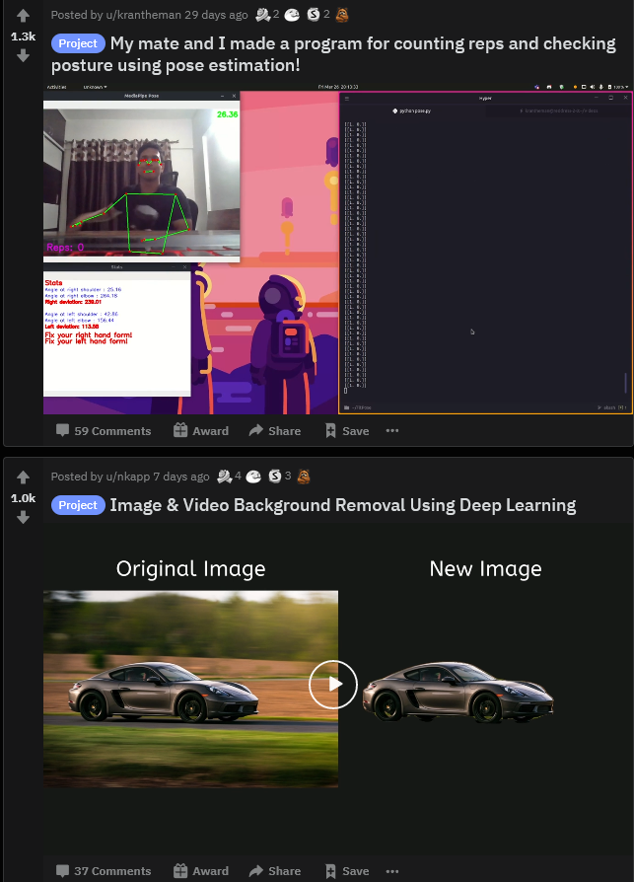
* Firstly these posts make good use of images, therefore i must link to the most attractive possible image/gif i can get, which i believe would be the afhqdog pretrained network combined with projector.py on one of my dog images
* 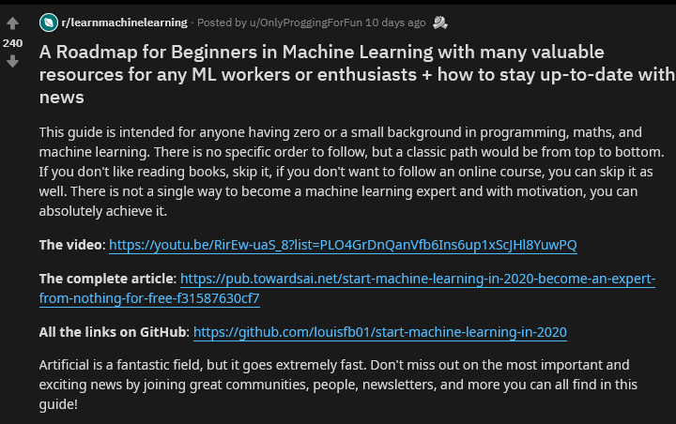
* For quite wordsy posts you can get away with a few paragraphs work but no more. It also generally seems better when it is better spaced
* That being said there has been a quite successful post which simply points to a github page and has a reasonably specific title
* 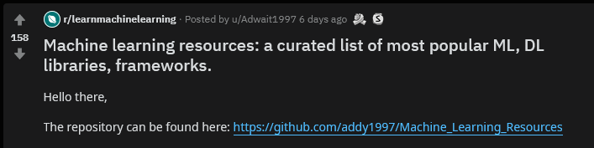
* This goes to show that the main necessity is the quality of the work, which hopefully people think i have
* 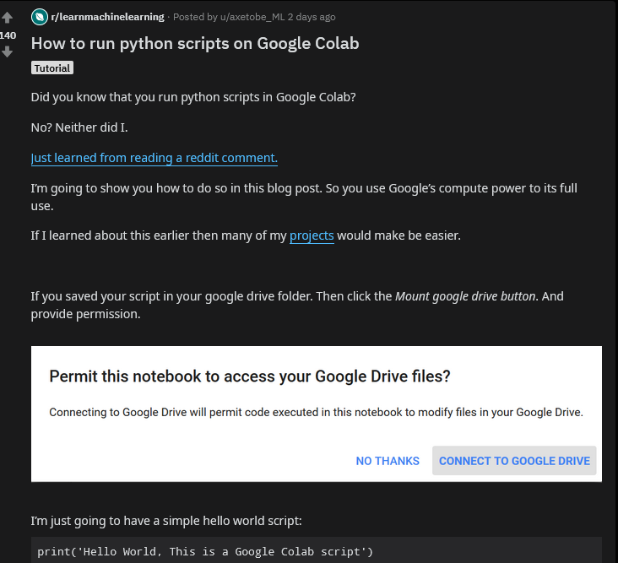
* Coincidentally there is also a post about running python scripts on colab, which is something i show people how to do, and therefore is clearly valuable
* After trying to get the best of all these posts this is what i came up with: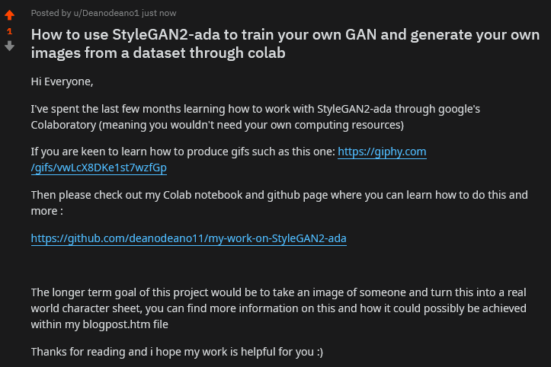
* This image will also be on the github page

# Conclusion

I have thoroughly enjoyed this module, it really has presented a new challenge that i quite frankly wasnt expecting out of first year. I have gained a lot of valuable experience and it has been an absolute pleasure to work with my lecturer John. Thank you for the experience.